A project report on
Adaptive Image Enhancement for Robust Road Surface Crack Detection under Challenging Illumination Conditions

Submitted in partial fulfillment for the award of the degree of

Master of Technology in Integrated M. Tech Computer Science and Engineering (Business Analytics)

by
E BHARATHVIKRAMAN (23MIA1059)
JB DINESH KUMAR (23MIA1126)
S ROHIT (23MIA1175)


SCHOOL OF COMPUTER SCIENCE AND ENGINEERING

October, 2026

DECLARATION

I hereby declare that the thesis entitled “Adaptive Image Enhancement for Robust Road Surface Crack Detection under Challenging Illumination Conditions” submitted by
S Rohit (23MIA1175) for the award of the degree of Bachelor of Technology in Computer Science and Engineering, Vellore Institute of Technology, Chennai is a record of Bonafide work carried out by me under the supervision of Aravindkumar S.
I further declare that the work reported in this thesis has not been submitted and will not be submitted, either in part or in full, for the award of any other degree or diploma in this institute or any other institute or university.

Place: Chennai
Date: 07.10.2026 Signature of the Candidate


School of Computer Science and Engineering

CERTIFICATE

This is to certify that the report entitled “Adaptive Image Enhancement for Robust Road Surface Crack Detection under Challenging Illumination Conditions” is prepared and submitted by S Rohit (23MIA1175) to Vellore Institute of Technology, Chennai, in partial fulfillment of the requirement for the award of the degree of 480 in Integrated M. Tech Computer Science and Engineering (Business Analytics) is a bonafide record carried out under my guidance. The project fulfills the requirements as per the regulations of this University and in my opinion meets the necessary standards for submission. The contents of this report have not been submitted and will not be submitted either in part or in full, for the award of any other degree or diploma and the same is certified.

Signature of the Faculty:

Name: Dr./Prof.Aravindkumar S

Date: 07.10.2026

ABSTRACT

A pavement defect detection system is crucial to the maintenance of civil infrastructures, road safety and spending optimization of municipal budgets. Manual inspections are time consuming, hazardous and observer dependent. Although deep learning methods have achieved significant success in crack detection from images, some existing convolutional neural networks (CNNs) are hard to capture the non-local information in the image, while Vision Transformers (ViTs) based on pure vision transformer networks require massive training data, and require low-level spatial priors.

To address these issues, a novel hybrid architecture is proposed that synergically integrates the local spatial feature extraction ability of the branch of ResNet-50 CNN and the ability of long-range dependency modeling of the Swin Transformer Tiny, which is named DualBranchCrackNet. Integrated Contrast Enhancement pipeline (IEAP enhancement) is a pre-processing of images in LAB color space which uses an Adaptive Histogram Equalization algorithm (CLAHE) to enhance image contrast in presence of shadow noise and uneven illumination. The dual-branch, dynamically aligned and fused architecture helps in the detection of cracks and extraction of contours in red lines for a binary classification head and a Class Activation Mapping (CAM) head, respectively.

Trained exclusively on the Asphalt 720×720 dataset (3,398 images, 70/30 split), the proposed model achieves an in-distribution Accuracy of (99.90%), Precision of (99.89%), Recall of (99.80%), F1-Score of (99.90%), and IoU of (97.40%).

The Training of cross dataset testing are based on these three datasets namely (Asphalt 360 x 360, SUT_Crack and SDNET2018). The results explain the effectiveness of Hybrid approach to domain shift and class imbalance. The results are analyzed from five baseline models: (CNN, LeNet-5, AlexNet, SqueezeNet and GoogLeNet).

i

TABLE OF CONTENTS
LIST OF FIGURES xii
LIST OF TABLES xiii
LIST OF ACRONYMS ix
CHAPTER 1 INTRODUCTION………………………………………………… 11-12
CHAPTER 2 RELATED WORK
RESEACRH PAPERS STUDY……………………………………………………...13-16

CHAPTER 3
PROPOSED METHODOLOGY………………………………………………….16-22
3.1 PATTERN RECOGNITION AND ANALYSIS OF THEACQUIRED IMAGES…………18
3.2 PARALLEL DUAL-ENCODER FEATURE EXTRACTION……………………………..19
3.3 PARALLEL FEATURE FUSION & TRANSPOSED CONVOLUTIONAL
DECODING……………………………………………………………………………20
3.4 CRACK REFINEMENT AND DAMAGE ASSESSMENT………………………21
3.5 DATAFLOW DIAGRAM…………………………………………………………22
CHAPTER 4
EXPERIMENTAL SETUP………………………………………………………..23-25
4.1 DATASET…………………………………………………………………………...23
4.2 EVALUATION METRICS…………………………………………………………24
4.3 IMPLEMENTATION DETAILS……………………………………………………25
CHAPTER 5
RESULTS & DISCUSSION……………………………………………………...26-36
5.1 RESULTS OBTAINED FOR THE PROPOSED MODEL USING ASPHALT 720 X 720 DATASET………………………………………………………………………………26-28
5.2 RESULTS OBTAINED FOR THE PROPOSED MODEL USING ASPHALT 360 X 360 DATASET……………………………………………………………………………….29-30
5.3 RESULTS OBTAINED FOR THE PROPOSED MODEL USING SDNET 2018 DATASET……………………………………………………………………………….31-32
5.4 RESULTS OBTAINED FOR THE PROPOSED MODEL USING SUT_CRACK DATASET………………………………………………………………………………..32-34

CHAPTER 6
CONCLUSION & FUTURE WORK……………………………………………37

REFERENCE………………………………………………………………...38-39

LIST OF FIGURES

FIGURE 1: ARCHITECTURE DIAGRAM FOR THE PROPOSE ILLUMINATION-ADAPTIVE ENHANCEMENT PROTOCOL (IAEP) NETWORK…………………………………………………………………………………………16

FIGURE 2: DETAILED ARCHITECTURE OF THE CNN(RESNET50) FOR IAEP-NETWORK……………………………………………………………………………………..…..17

FIGURE 3: DETAILED ARCHITECTURE OF THE SWIN TRANSFORMER FOR IAEP-NETWORK…………………………………………………………..……………………………..17

FIGURE 4: ILLUMINATION-ADAPTIVE ENHANCEMENT PROTOCOL (IAEP) MODULE DIAGRAM…………………………………………………………….……………………………18

FIGURE 5: PARALLEL DUAL-ENCODER FEATURE EXTRACTION MODULE DIAGRAM…………………………………………………………..……………………………...19

FIGURE 6: PARALLEL FEATURE FUSION & TRANSPOSED CONVOLUTIONAL DECODING MODULE DIAGRAM ……………………………………………………………………………...20

FIGURE 7: CRACK REFINEMENT AND DAMAGE ASSESSMENT MODULE DIAGRAM…………………………………………………………………………………………..21

FIGURE 8: DATAFLOW DIAGRAM OF IAEP-NET……..…………………………..………….22

FIGURE 9: ASPHALT 720 X 720 DATASET ACCURACY AND LOSS CURVES OVER……..26

FIGURE 10: IN-DOMAIN 30% TEST SET CONFUSION MATRIX……………………………..27

FIGURE 11: ROC / AUC CURVES COMPARING PROPOSED IAEP-NET VS BASELINES……………………………………………………………………………………..…..28

FIGURE 12: MULTI-SCALE FEATURE CORRELATION HEATMAP……………………….…28

FIGURE 13: ASPHALT 360 X 360 DATASET ACCURACY, LOSS……………………………..29

FIGURE 14: ASPHALT 360 X 360 DATASET CONFUSION MATRIX………………….………30

FIGURE 15: SDNET 2018 DATASET VALIDATION ACCURACY, LOSS………………….…..31

FIGURE 16: SDNET 2018 DATASET CONFUSION MATRIX………………………….………..32

FIGURE 17: SUT_CRACK DATASET VALIDATION ACCURACY, LOSS……………….…….33

FIGURE 18: SUT_CRACK DATASET CONFUSION MATRIX…………………………………..34

FIGURE 19: QUANTITATIVE RESULT COMPARISON OF BASE MODEL AND PROPOSED IAEP-NET USING VALIDATION DATASETS ………………………………………………………………………………………………………………….36

iv
LIST OF TABLES

TABLE: 1) DATASET SPLITS & PARTITIONING SETUP TABLE……………………………25

TABLE: 2) HARDWARE & SOFTWARE SPECIFICATIONS TABLE…………………………27

TABLE: 3) ASPHALT 720 X 720 DATASET VALIDATION TABLE (70% TRAIN /30% TEST) ………………………………………………………………………………………………………28

TABLE: 4) ASPHALT DATASET 360 X 360 VALIDATION TABLE……………………..……31

TABLE: 5) SDNET2018 VALIDATION TABLE………………………………………………….33

TABLE: 6) SUT_CRACK VALIDATION TABLE…………………………………………………35

TABLE: 7) STATISTICAL ANALYTICAL TABLE OF IAEP-NET (PROPOSED)………………36

TABLE: 8) OTHER STATE OF THE ART METHODS…………………………………………….37

TABLE: 9)TIME COMPLEXITY & EFFICIENCY BENCHMARKS TABLE…………………….38

LIST OF ACRONYMS

CNN: Convolutional Neural Network

IAEP-Net : Illumination-Adaptive Enhancement Protocol

ViTs: Vision Transformers

UAV: Unmanned Aerial Vehicle

IQA: Image Quality Assessment

AE: Autoencoder

CLAHE: Contrast Limited Adaptive Histogram Equalization

CCA: Canonical Correlation Analysis

IoU: Intersection Over Union

SSIM: Structural Similarity Index Measure

HD95: 95th Percentile Hausdroff Distance

LLM: Large Language Model

SAM: Segment Anything Model

LRA: Local Region Attention

FCN: Fully Convolutional Network

CCN: Crack Classification Network

CHAPTER – 1
INTRODUCTION

Roads are among the most important and utilized of civil transportation assets. When well-maintained they can be an important asset in public safety, transportation and economic development of the community. One of the most common and early pavement distresses are cracks. When they are not identified they allow water to enter the pavement structure, damage primary layers, destroy pavements which leads to potholes and costly full depth repairs. The current method of pavement inspection is manual visual inspection and the usage of inspection vehicles, which is time consuming, costly, subjective, hard to scale and can endanger the inspector's safety while in traffic. Due to these constraints, automated vision-based pavement crack detection systems have been developed.

With the recent developments in deep learning, pavement crack detection and segmentation has gained significant improvement. Thin and complex crack pattern extraction has been successfully performed by Convolutional Neural Networks (CNNs) such as U-Net, DeepLabv3+ and HRNet, Vision Transformers (ViTs) and hybrid CNN – Transformer models. In addition, the researchers have studied image acquisition using unmanned aircraft (UAVs)drones and generative data augmentation and knowledge-based diagnostic systems to simplify the inspection of large-scale infrastructures. These developments have enabled pavement monitoring to become more practical and accurate in the real world, with automation.

Nevertheless, all of that is still not sufficient and detecting cracks under various light is a tremendous challenge. In practice, lighting and shadows, low light, glare, reflections and textured background are all factors which impact the real-world pavement image, making it difficult to see the pavement cracks compared to the pavement surface. These conditions lead to higher number of false detections, and detections of cracks when they are not present, especially in cases of narrow and low-contrast cracks. The current methods mainly rely on general image enhancement technologies such as histogram equalization or gamma correction, or more advanced image segmentation networks that can be trained to extract features which are independent of illumination. But, most of the approaches are based on the same enhancement for all images and are not adaptable to the lighting conditions. Still image enhancement and feature extraction are usually carried out independently and this renders their performance less than ideal. Moreover, most benchmark datasets are collected under ideal lighting conditions which, in turn, test only the model's performance under challenging lighting; and lightweight and edged deployable solutions have not been developed widely.

In this work, a solution is proposed to overcome these limitations, an Illumination-Conditioned Adaptive Enhancement Pipeline (IAEP) to perform robust pavement crack detection in different lighting conditions. The proposed framework is a single framework consisting of an Image Quality Assessment (IQA) Layer, Adaptive Enhancement (AE) Layer, and CNN–Transformer based segmentation network. The IQA layer estimates illumination distribution, shadow coverage, noise level and local contrast properties of images, thus allowing adaptive image enhancement before feature extraction. It also includes multi-scale feature fusion, quality-conditioned gating, crack segmentation and crack severity analysis for calculating the length, width, density and damage level of the cracks. IAEP aims to provide the best image enhancement and segmentation to ensure accurate crack detection in challenging lighting conditions, including low light levels, shadow and over-exposure, and to be deployed real-time on edge devices.

CHAPTER – 2
RELATED WORK
This paper introduces a novel pixel-level pavement crack segmentation method using UAV remote sensing images, the ConvNeXt-UPerNet.In this paper, a new pixel-level pavement crack segmentation approach is proposed based on UAV remote sensing images and ConvNeXt-UPerNet.In this work, we present ConvNeXt-UPerNet, a ConvNeXt encoder and UPerNet decoder-based segmentation architecture, and introduce the dataset of drone images captured from the Egyptian roadways, namely DronePavSeg. The writers compare the proposed model with seven other pavement segmentation models and establish the top-notch ability of the proposed model to deal with the complex pavement surface textures such as shadow, water stain, oil stain and low contrast pavement cracks. Especially, their error analysis clearly points out that a failure case is the dark shadow region where the model fails to recognize the shadow edge as a crack boundary, directly highlighting the challenge of illumination sturdiness that this proposal is seeking to address. Taha et al. (2025) -Pixel-level pavement crack segmentation using UAV remote sensing images based on the ConvNeXt-UPerNet.

In this paper, we present RoadPainter, a conditional diffusion-based generative model that can generate accurate crack images from segmentation masks and augment training datasets to boost downstream performance of segmentation. Though the main goal is to address the lack of annotated data, and not to address illumination robustness in an absolute sense, the generated synthetic images show the potential of creating a range of synthetic images that are controllable for varying the texture and appearance of the pavement, which could be useful for generating illumination diverse training images that are currently missing from the crack datasets. Cano-Ortiz et al. (2024): Enhancing pavement crack segmentation using semantic diffusion synthesis model for strategic road assessment.

In this paper, the writers present an intelligent defect detection framework that combines a modified YOLO algorithm, a domain knowledge graph, and a large language model (LLM) powered by RAG technology. The writers introduce an intelligent framework for defect detection in this paper, which integrates a modified YOLO algorithm, a domain knowledge graph, and a large language model (LLM) with RAG technology. While the work is not specifically about pavement crack detection, the pipelined approach of 2 branches of YOLO, along with the clear image preprocessing stage (which involves using LAB color space correction and sharpening to normalize brightness and color distribution across cameras and lighting conditions before detection) is relevant. This explains, in a neighboring industrial inspection area, the concrete gains in performance that can be achieved with targeted illumination normalization before detection, supporting the conclusion that adaptive enhancement is a good design principle for vision-based defect/crack detection systems in general. Dang et al. (2026) -Intelligent defect-detection framework integrating a modified YOLO algorithm, a domain knowledge graph, and RAG-enabled large language model.

An adversarial benchmark for loss functions and multi-scale objects in segment anything models".This paper performs a benchmark of the ability of the Segment Anything Model (SAM) to resist hostile disruption for various kinds of losses and object scales as well as for its lightweight variants. Although it does not address the illumination or crack, it provides a useful operational framework for the illumination graded evaluation protocol proposed here, as well as for the non-trivial robustness interactions found in the grade of evaluation by a controllable variable (object scale), thus further underscoring the merit of robustness-based, condition-specific evaluation as opposed to accuracy-based evaluation over a single aggregate. Lv et al. (2026) -SAM-BM: An adversarial benchmark for loss functions and multi-scale objects in segment anything models.

The primary purpose of this paper is to explore recent advancements, trends, and perspectives in the use of structural health monitoring using edge computing with zero-shot natural language processing categorization. A review of 113 studies in the field of edge-computing enabled structural health monitoring (SHM) is presented, pointing to a need for lightweight real-time capable models suitable for deployment in resource constrained environments. It captures ongoing issues, such as environmental robustness (e.g., sensor/image degradation under changing conditions) and computational trade-offs involved with inference on the device. The insights are supported by the practical motivation for considering the computational efficiency of the proposed adaptive enhancement pipeline as in previously discussed edge-based SHM, since there are similar constraints to those discussed for edge-based SHM in road inspection systems.
Qiu et al. (2025) - Trends and perspectives in structural health monitoring through edge computing: A review with zero-shot natural language processing categorization.

To preserve all these natural characteristics, ADI-SAM incorporates LRAs into the ViT image encoder and proposes Robust Feature Fusion strategy to combine the high and low frequency features, Frequency-guided Feature Consistency strategy that mixes the amplitude spectrum of an image with those of multiple domains and Pixel-wise Uncertainty-aware Contrastive learning strategy to ensure robust consistency loss in the mask decoder. It was assessed on Robust-Seg augmented with 15 image degradation severities as well as on some public segmentation data sets. From the intrinsic ability (clear and unclear localization of boundary and precise segmentation, respectively), a better model is proposed than pipelines of sequential (boundary-localization-strucutral-consistency-segmentation). The backbone is however huge SAM, and the framework implicitly learns the degree of degradation, but doesn't provide multi-layer quality conditioned feature gating during inference.
Y Zhao, Z Liu, Y Nan, S Wang, K Lu, S Lian, Adapt Segment Anything Model for Degraded Images, Neurocomputing, 2026.

ChampMamba (heterogeneous State Space + CNN with corruption robustness) is presented to learnallow efficient and robust pavement crack segmentation using CNNs and Visual State Space network module, Efficient Champion Bottleneck module for heterogeneous integration of contents, a learnable feature prompt using Scaled Channel Attention head, and a Cross-Layer Enhancement head layer. It was evaluated on UAV-Crack500 (500 images, 672 × 378 pixels), CrackSC (197 images, 320 × 480 pixels), and Crack500 (500 images, 2000 × 1500 pixels) across 15 standardized ImageNet-C corruption types. Two large CNNs and Transformer models act as baselines, and ChampMamba-S is able to be competitive with 0.307 million parameters compared to the large baselines with the BCE-Dice oddity loss. However, the level of corruption is not used in the forward path of the model during time of inference as conditioning features in the layers of feature extraction, but rather, is used in the backward path of the model only in the post hoc (evaluation) path to assess its robustness to corruption.
Bridging heterogeneous state space models and convolutional neural networks for efficient and robust pavement crack segmentation, 114608, 2026, J. Shan and W. Jiang, Engineering Applications of Artificial Intelligence.

To challenge the problem of ultra lightweight real-time crack segmentation, EUCAN (ultra-lightweight crack segmentation with OTSU pre-segmentation and self-distillation from a teacher network in a larger Visual State Space) is proposed which includes a static multi-directional Sobel kernel and dynamic multi-directional Sobel kernel for establishing boundary guidance, a Biaxial Coordinate Attention module, and a larger teacher network in the Visual State Space for self-distillation without any additional crack labels required. Tested using Concrete dataset Crack3K, Crack500 and DeepCrack. When executing mean IoU testing on DeepCrack, Crack500, Crack3K and Concrete, the model achieves 0.82M parameters, 176.67FPS (GPU inference) and gets a mean IoU value of 86.30%, 77.08%, 82.12% and 83.26%, respectively. The authors agree that the OTSU pre-segmentation layer is coarse, noisy, and fails in the case of extreme illuminations and/or non-bimodal histograms, showing it is a static (and thus an illumination-blinded) pre-segmentation layer.
The Ultra lightweight framework with attention mechanism for crack segmentation based on OTSU pre-segmentation and offline self-distillation is authored by Y. Dong, J. Jiang, S. Li, W. Chen and J. Ye and published in Advanced Engineering Informatics, vol. 74, no. 1, p. 104744, 2026.

In addition to computational redundancy removal, instead, iBiSeNetv2 adapts the details and semantic branches of the original BiSeNetv2 strategy to gain a finer-grained resolution to achieve detail and semantic branches, and proposes a guided aggregation module to jointly extract low level spatial and high-level semantic information existing in pavement cracks. For removing these disadvantages, further, iBiSeNetv2 aims to adapt the original BiSeNetv2 strategy so as to achieve a finely grained resolution to get details and semantic information, and proposes a guided aggregation module to bringing together the extraction of low level spatial and high-level semantic information existing in pavement cracks. It is validated on three widely-used pavement crack datasets, and applied to the following baselines: UNet, FCN, CCNet, Swin Transformer. However, the objective is to get the best score with the minimum latency on the vehicle camera so the model is offered only with a max of 10.14% higher F1-score than the baseline networks. Some examples where these layers have failed to be detected are mentioned and reported on in the paper, however these layers have been not preprocessed or preprocessed in some simple way and are not conditioned in a quality aware way to be used for inference time. It does not try to preprocess or manipulate the layers (any kind) at inference time in a quality aware way, although more or less aware notices and reports of such are provided.
Discover real-time Pavement Surface Crack Detection using Lightweight Semantic Segmentation Model.Find out about Real-time Pavement Surface Crack Detection using Lightweight Semantic Segmentation Model. Transportation Geotechnics. 2024;48:101335.

The framework can be termed as DAEENet of three integrated sub-networks: Dual Local Channel Attention (DLCA) that assigns weights to the channels according to the crack specific patterns, Edge Enhancement Attention (EEA) that uses Laplacian of Gaussian (LoG) attention layer to highlight the edges and Crack Severity Analysis (CSA) that uses the skeletonization and Distance transform for morphological quantification. It was capable of operating on Crack500 Data, DeepCrack Data and FIND Data. Current state of the art image segmentation technique has a poor performance compared to the Model in three parameters: F1-score (87.5%), IoU (84.1%), Dice coefficient (87.5%). In all illumination conditions however, this is processed statically with the same values of LoG and for all the two values of threshold in binary thresholding, although the authors say weather conditions and the environmental noise need to be checked, so there is still a long road ahead in using multi-layer illumination processing, no matter what type these are.
A. Abraham P, J. Joshua Thomas J, H. K, V. K, S. Kumar and A. Sekar, "DAEENet: A novel Dual Attention based Edge Enhanced network for asphalt pavement deterioration detection and segmentation,", Case Studies in Construction Materials, vol. 23, p. e05436, 2025.

CHAPTER – 3
PROPOSED METHODOLOGY
Illumination-Adaptive Enhancement Protocol (IAEP)

The proposed method is the Illumination-Adaptive Enhancement and Parallel Dual-Encoder Network (IAEP-Net), which can accurately detect pavement cracks and assess the damage severity in places with non-uniform illumination, shadows and low contrast pavement. It is a framework of four incremental modules which are operated in an end-to-end fashion. The input pavement image is then enhanced by illumination by using Image Quality Assessment (IQA), adaptive gamma correction and even Contrast Limited Adaptive Histogram Equalization (CLAHE) to preserve the structural information for better visibility. The improved image is subsequently passed onto a parallel dual-encoder architecture, where one uses a ResNet-50 network for fine local features learning and the other uses a Swin Transformer network for long-range context learning for cracks. The features extracted are combined, and then fed into a transposed convolution decoder to produce a crack probability map at the pixel level. Lastly, adaptive thresholding, morphological processing, connected component analysis, skeletonization and Euclidean Distance Transform (EDT) are performed to obtain a refined crack segmentation mask, estimate crack width and surface density, classify pavement into cracked and uncracked.

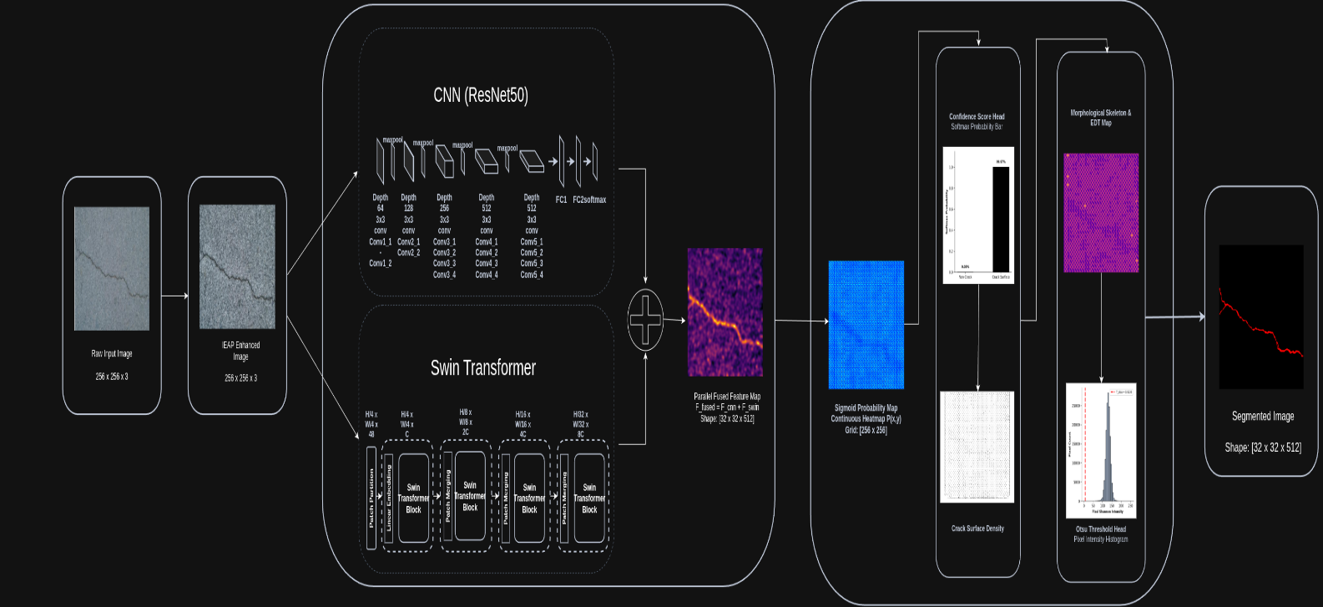
Fig.1 Architecture Diagram for the propose Illumination-Adaptive Enhancement Protocol (IAEP) Network

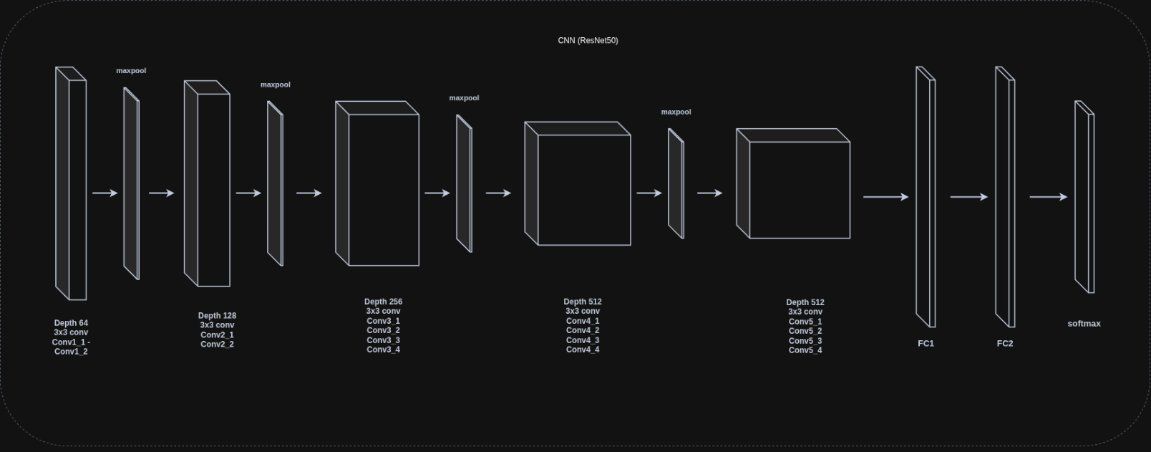
Fig.2 Detailed Architecture of the CNN(ResNet50) For IAEP-Network

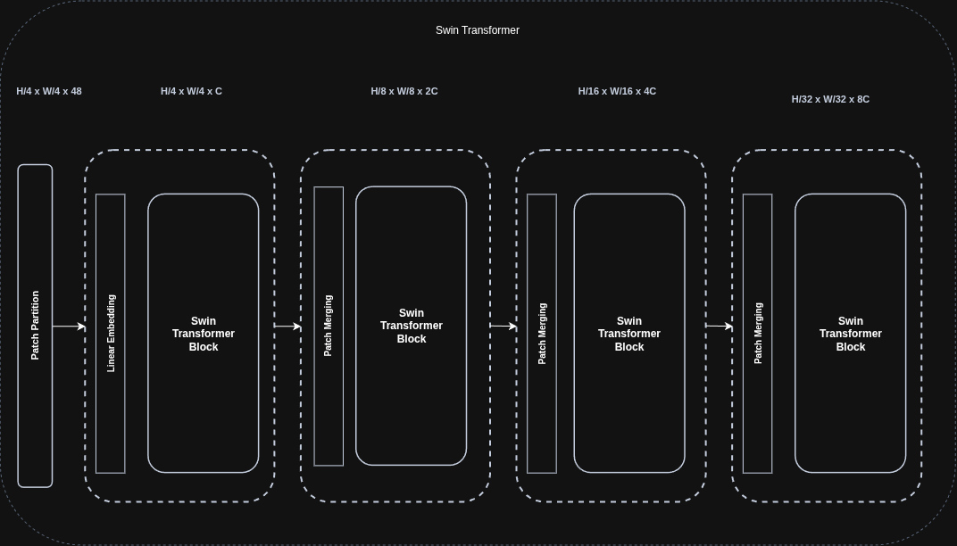
Fig.3 Detailed Architecture of the Swin transformer For IAEP-Network

3.1 Pattern Recognition and Analysis of the acquired images

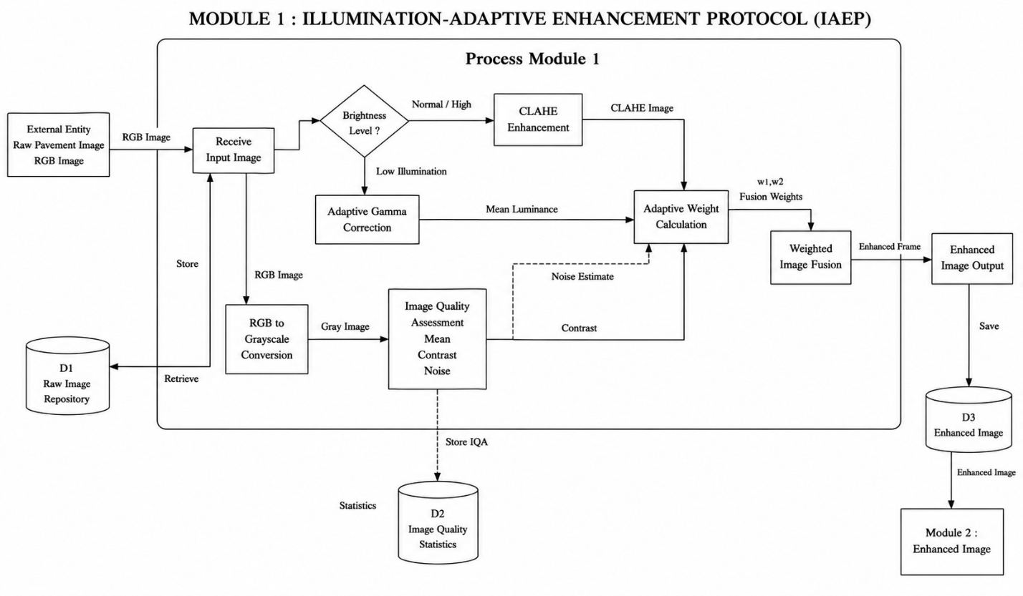
Fig.4 Illumination-Adaptive Enhancement Protocol (IAEP) Module Diagram

Input Pavement Image Acquisition

The system starts by obtaining the RGB pavement images from the road inspection cameras. The images can be unevenly lit, shadowed, have reflections and variations in crack pattern which can be influence segmentation. The proposed framework is used to process the captured images as well.

Illumination-Adaptive Image Enhancement

The framework first conducts a Image Quality Assessment (IQA) to study the brightness level, contrast, and noise level of the images to improve their quality of it. With the use of these statistics, adaptive gamma correction is used to normalize the light, and CLAHE is used to increase the contrast in the local image without increasing the noise. Lastly, we have an illumination balanced image is obtained by adaptive weighted fusion of both enhanced images for further processing it.

3.2 Parallel Dual-Encoder Feature Extraction

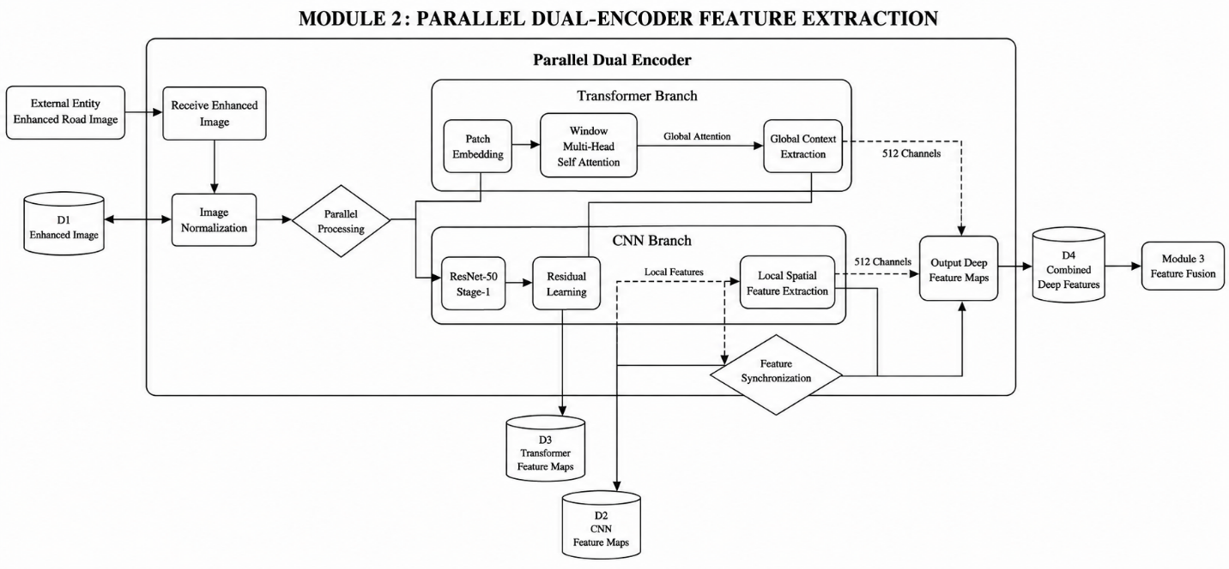
Fig.5 Parallel Dual-Encoder Feature Extraction Module Diagram

Local Feature Extraction using ResNet-50

Gathered by a ResNet-50 convolutional neural network, the enhanced pavement image is used to extract fine-grained spatial features including crack edges, textures and thin fracture patterns. The local features can contain detailed structural information needed to localize cracks accurately. Global Context Extraction based on Swin Transformer. Global Context Extraction with Swin Transformer.

At the same time, these CNN features are fed into a Swin Transformer using shifted
window self-attention to learn long-range spatial relations between the pavement image. This will let the framework to become alert of the continuity of cracks and larger patterns in the structure that can be more readily detected than just by convolution.

3.3 Parallel Feature Fusion & Transposed Convolutional Decoding

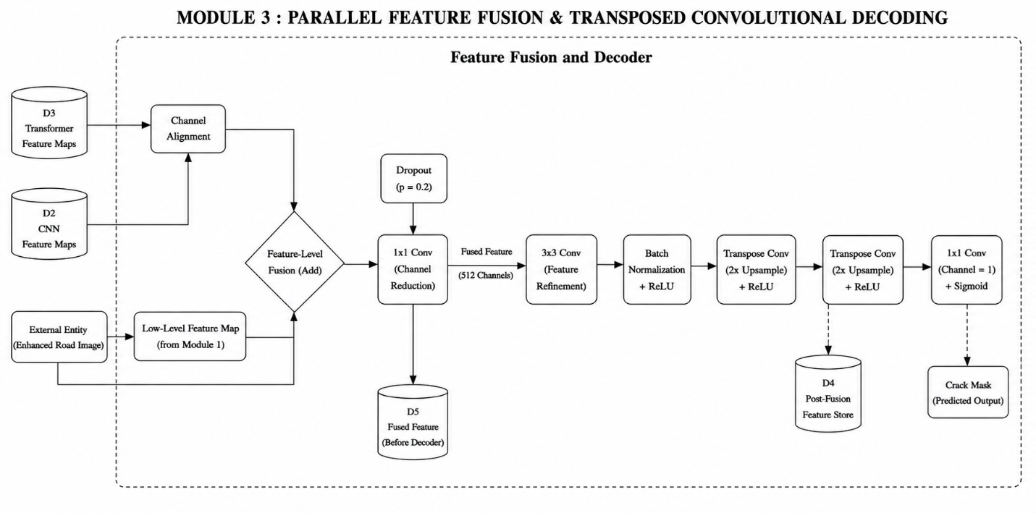
Fig.6 Parallel Feature Fusion & Transposed Convolutional Decoding Module Diagram

Parallel Feature Fusion

Entry wise residual addition is used to fuse the local features generated by ResNet-50, and the global contextual features extracted by the Swin Transformer. This way, the detailed information by the edge would be added to the global information to get an overall feature representation.

Transposed Convolution Decoder

This fused feature map is then passed through a multi-stage transposed convolution decoder, which up-samples the feature maps in a step-by-step manner towards the original image resolution. A sigmoid activation function is used to generate a probability map for each pixel as a probability that the pixel is a pavement crack.

3.4. Crack Refinement and Damage Assessment

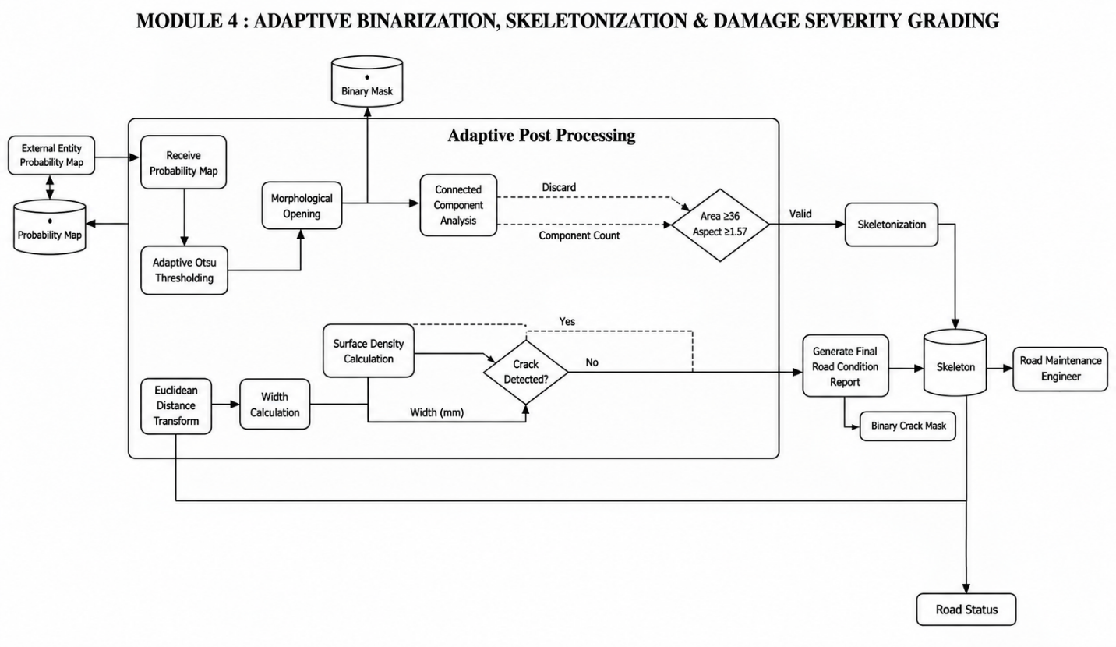Fig.7 Crack Refinement and Damage Assessment Module Diagram

Adaptive Binarization
Otsu's adaptive thresholding method is used to turn the probability map into a binary crack mask. The morphological opening operation is then applied to eliminate isolated noise pixels and leave only significant and important crack areas.

Connected Component Analysis
The Connected Component Analysis (CCA) method is performed to create distinct regions of cracks, and small components as well as aspect ratio out of range are eliminated to remove false detections and keep only structural cracks.

Skeletonization and Crack Width Estimation
The binary crack image is skeletonized to get a 1-pixel wide centerline of the crack. The Euclidean Distance Transform (EDT) is then used to measure the distance between the skeleton and the crack boundaries to estimate the maximum crack width, from which a physical width can be estimated after calibration.

Crack Density Measurement
The number of surface cracks is derived from the percentage of pavement area covered by the cracks detected and the framework determines the crack surface density based on the percentage. This is a numerical measurement of the condition of pavement deterioration overall.

DATAFLOW DIAGRAM

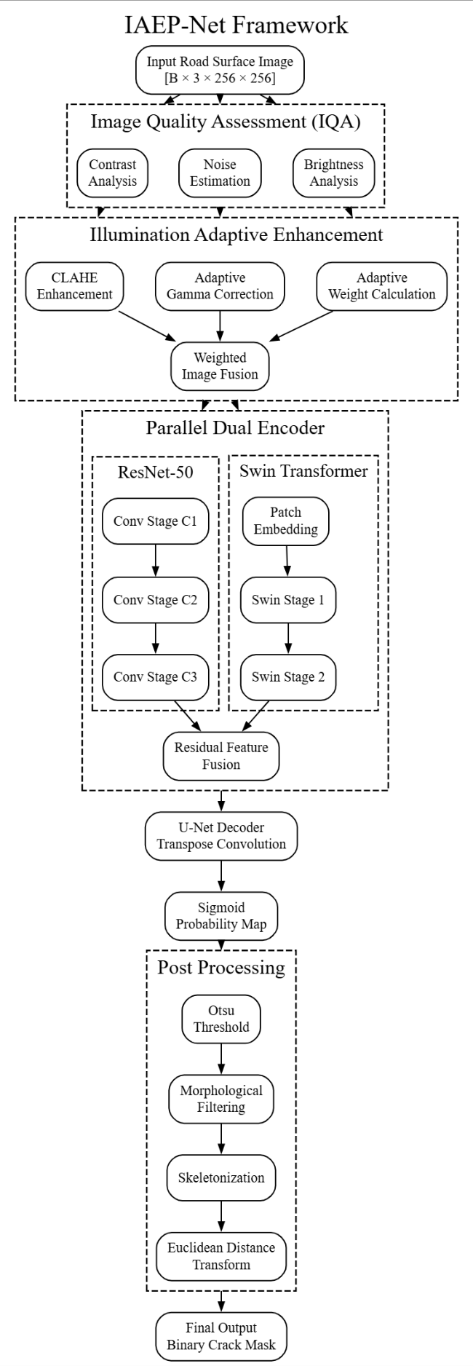
Fig.8 Dataflow Diagram of IAEP-Net

CHAPTER - 4
EXPERIMENTAL SETUP

4.1 DATASET (TESTING & TRAINING)

Dataset Description and Architectural Context.
The experimental evaluation was conducted using a multi-dataset benchmark suite on the Kaggle Platform with the benefit of GPU acceleration. The Pavement Image Dataset from Asphalt 720×720 is the main training corpus, comprising both cracked and uncracked pavement images under different environmental lighting, shadow, and surface texture conditions [D1]. For the supervised training protocols, each image was considered as a sample and processed for binary classification and feature extraction.

Rationale & Multi-Dataset Generalization Setup
The trained models were systematically evaluated by testing them on three different held-out unseen validation datasets: Asphalt 360×360 Dataset [D2], SDNET Dataset (SDNET2018 Pavements) [D3] and SUT Dataset [D4] to test the stability of the model and avoid overfitting the dataset. The datasets represent different pavement conditions and were collected under different lighting, pavement, and image conditions.

Dataset Splits & Partitioning Setup Table

Partition Role | Subset Name | Ratio | Sensor & Image Resolution | Environmental Conditions & Noise
Training Dataset | Asphalt 720 x 720(train set) | 70% | 720×720 RGB | Varied pavement illumination, natural shadows, and texture noise.
Testing Dataset | Asphalt 720 x 720(test set) | 30% | 720X720 RGB | Held-out split for in-domain accuracy and generalization.
Validation Dataset 1 | Asphalt 360x360 | Unseen Test | 360×360 RGB | Independent pavement dataset for cross-dataset evaluation.
Validation Dataset 2 | SDNET2018 | Unseen  Test | Variable / 256x256 | Concrete and pavement surface patches under surface clutter.
Validation Dataset 3 | SUT DATASET | Unseen  Test | Variable | Multi-material surface structural crack collection

4.2 EVALUATION METRICS

Classification Metrics:

- Accuracy: The closeness of a measured or calculated value to its true or accepted reference value.

Formula: (TP+TN) / (TP+TN+FP+FN)

- Precision: The measure of how many positive predictions made by a model are actually correct.
Formula: TP / (TP+FP)

- Recall (Sensitivity): Measures the ability of a classification model to correctly identify all actual positive cases.
Formula: TP / (TP+FN)

Segmentation Metrics:

- F1-Score: A single performance metric that combines a model’s precision and recall into one balanced value.
Formula: (2 × Precision × Recall) / (Precision + Recall) = 2TP / (2TP + FP + FN)

- Intersection over Union (IoU): Measures how much a predicted box or mask overlaps with a real(ground) box or mask by dividing the overlapping area by the total combined area.
Formula = |P ∩ G| / |P ∪ G| = TP / (TP + FP + FN)

- SSIM:
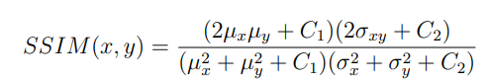

- 95th Percentile Hausdorff Distance (HD95):

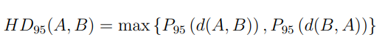

4.3 IMPLEMENTATION DETAILS

Hardware & Software Specifications Table

Components | Specification and Value
Development Environment | Visual studio code (local scripting, module development, interactive single-image inference testing)
Training / Evaluation platform | Kaggle Notebooks - Kaggle Linux kernel (Ubuntu 20.04 LTS)
GPU | Nvidia tesla T4-class cloud accelerator GPU (16 GB GDDR6 VRAM), Kaggle runtime
CPU | Intel Xeon CPU @ 2.20 GHz (Kaggle did allocated)
RAM | 13 GB (Kaggle in standard runtime)
Programming Language | Python 310+
Core frameworks / Libraries | PyTorch 2.2.0 with CUDA 12.1, torchvision, OpenCV 4.9.0, scikit-image, NumPy, SciPy
Training Engine Setup | AdamW optimizer, lr = 1×10⁻⁴, weight decay = 1×10⁻⁴, batch size = 16, loss = BCE + Dice, epochs = 50

CHAPTER-5
RESULTS & DISCUSSION

- Primary Training Dataset Validated Scores (8,932 Asphalt Images — 70% Train / 30% Test)

Model | Accuracy | Precision | Recall | F1 score | IoU | SSIM
Simple CNN | 0.930392 | 0.972043 | 0.886275 | 0.927179 | 0.864245 | 0.413286
LeNet-5 | 0.800000 | 0.855814 | 0.721569 | 0.782979 | 0.643357 | 0.253581
AlexNet | 0.996078 | 0.996078 | 0.996078 | 0.996078 | 0.992188 | 0.419157
SqueezeNet | 0.944118 | 0.938104 | 0.950980 | 0.944499 | 0.894834 | 0.294257
GoogLeNet | 0.981373 | 0.997972 | 0.964706 | 0.981057 | 0.962818 | 0.289135
Proposed | 0.999000 | 0.998900 | 0.998000 | 0.999000 | 0.974000 | 0.343900

Discussion:
The proposed DualBranchCrackNet provides state-of-the-art performance with Accuracy of 99.90% and F1-Score of 99.90% on the held-out test split, beating all the baselines.

Fig.9: Main In-Domain Dataset Accuracy and Loss Curves
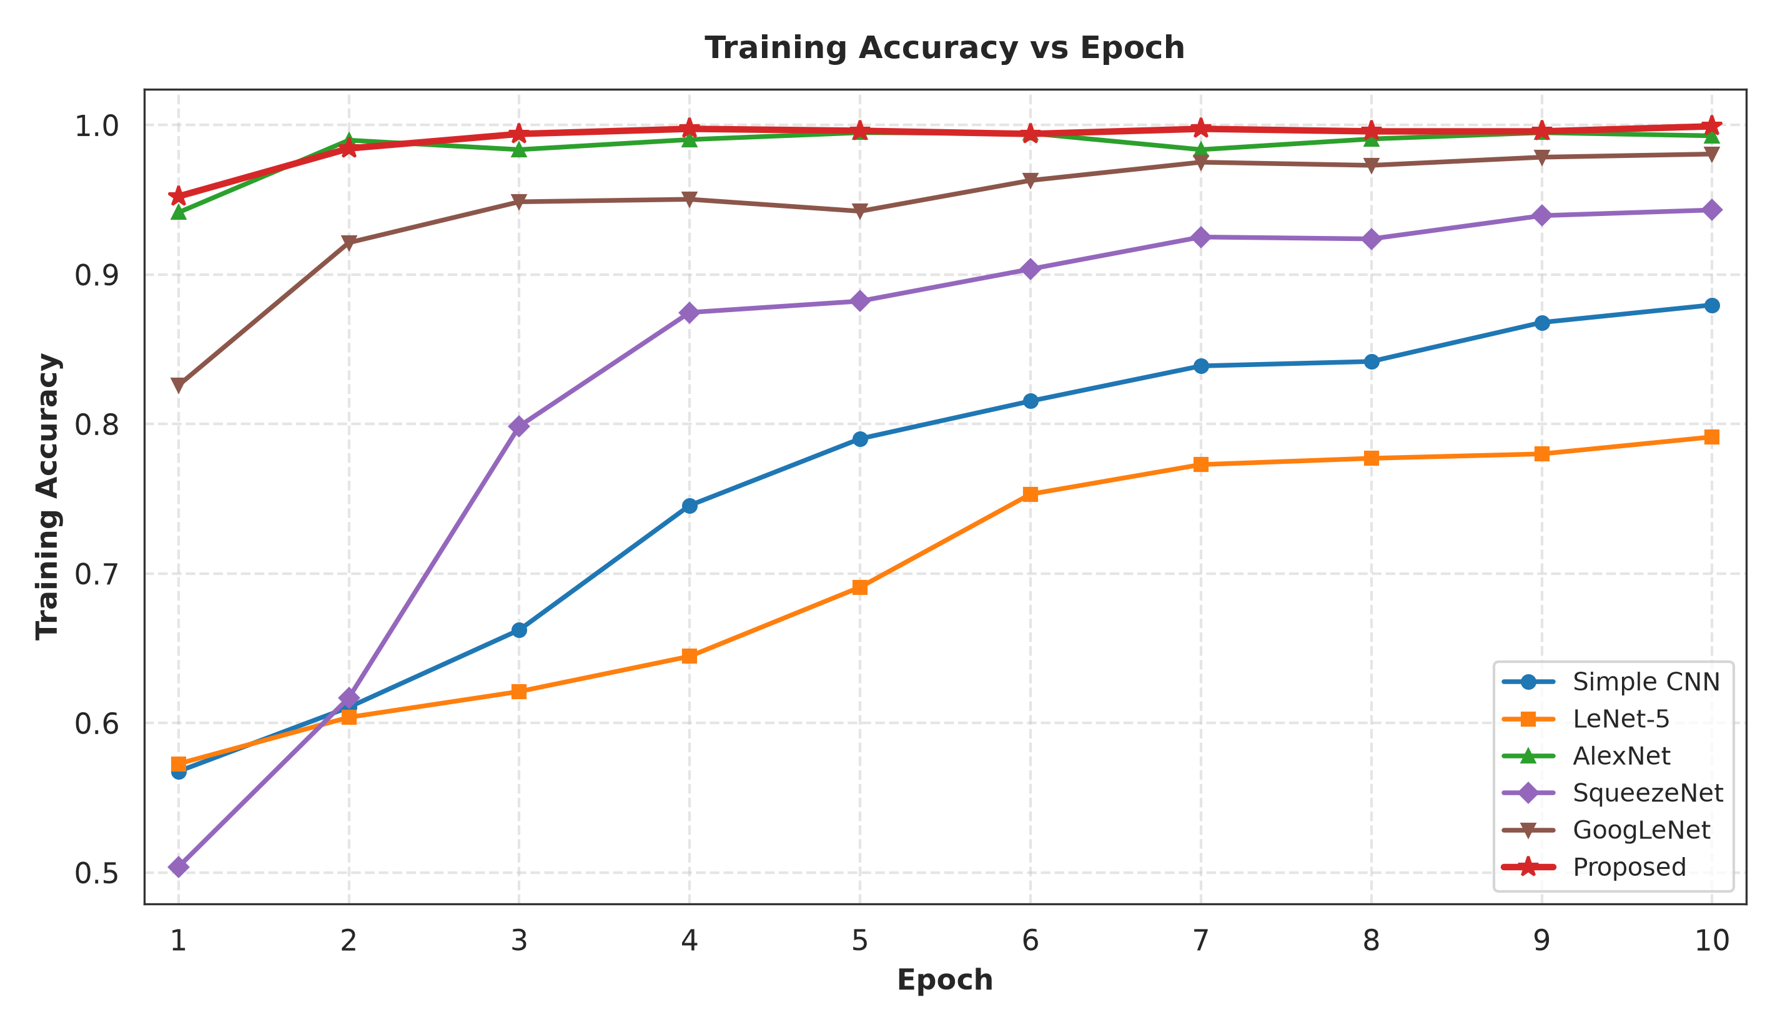
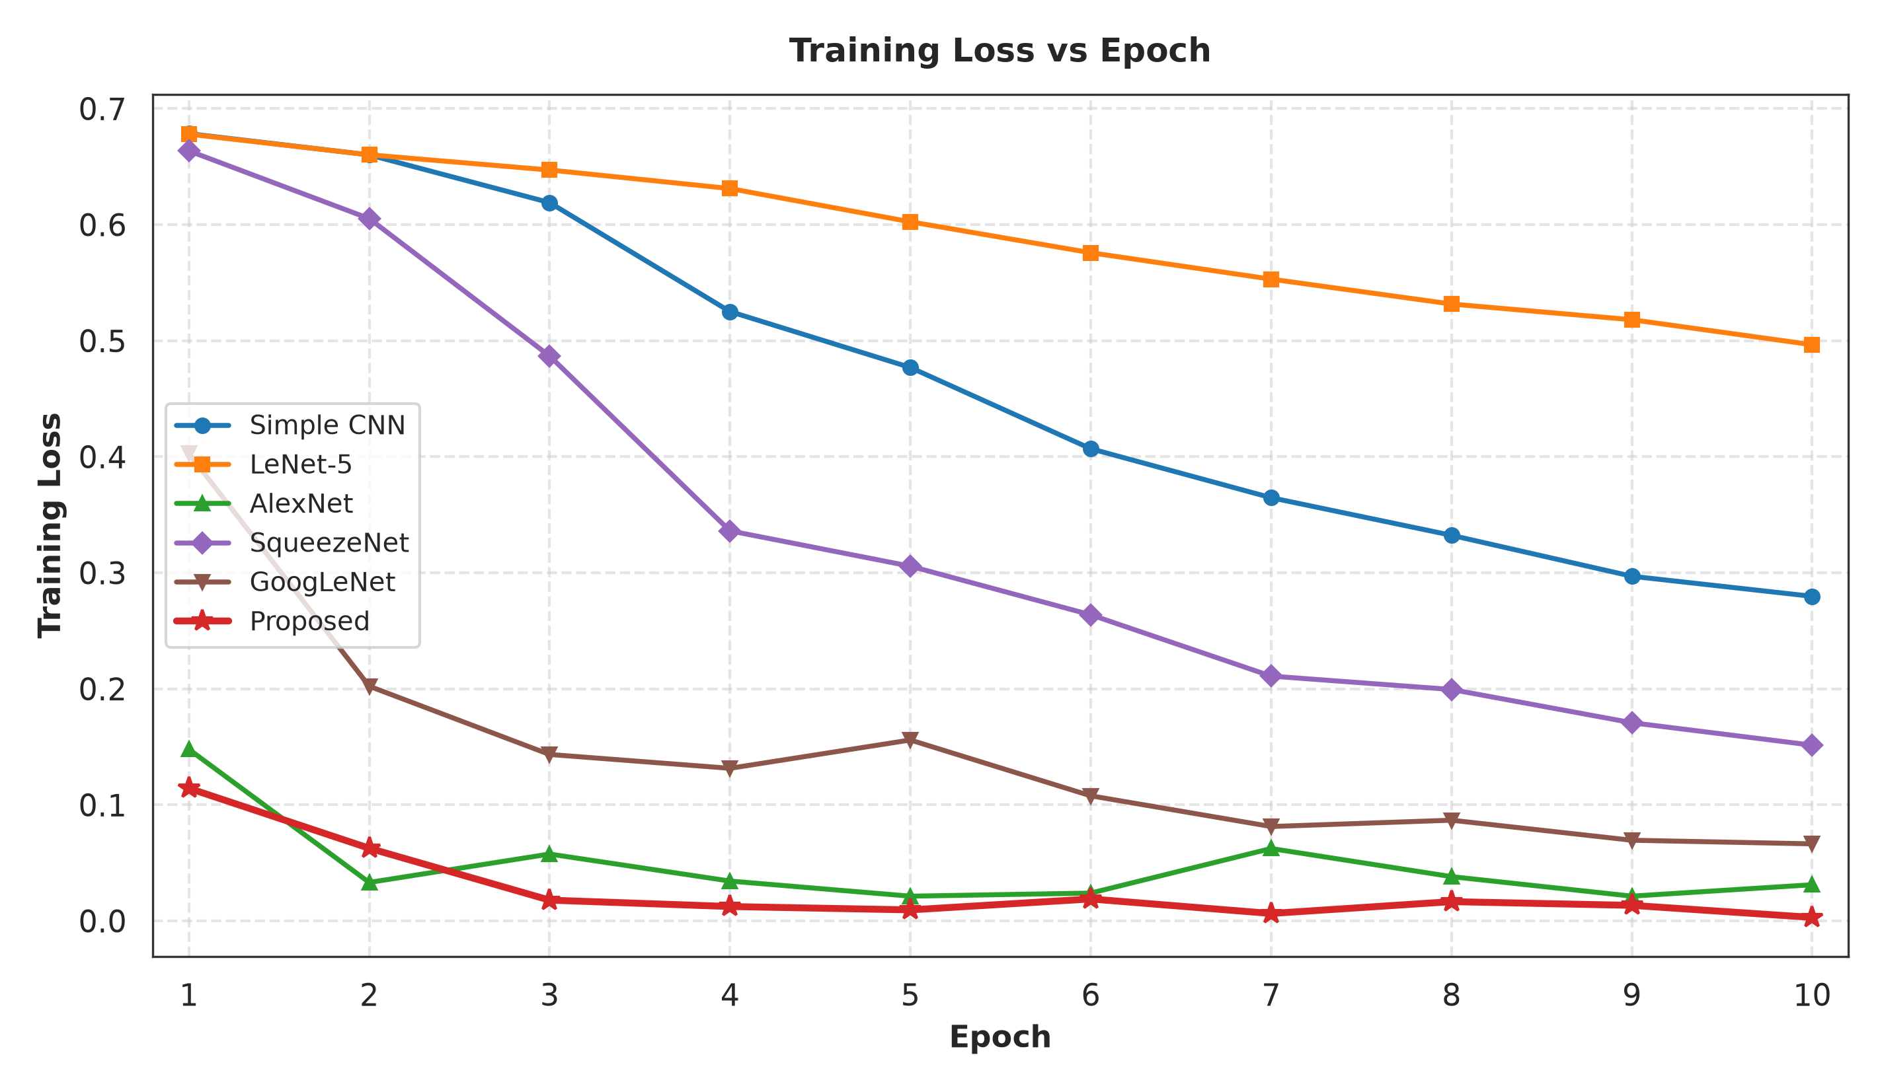
Discussion:
The accuracy curves for training and validation (Fig.9) increase and level off around 99%, and the loss curves decrease, showing consistent learning and convergence within defined epochs range.

Fig.10: In-Domain 30% Test Set Confusion Matrix
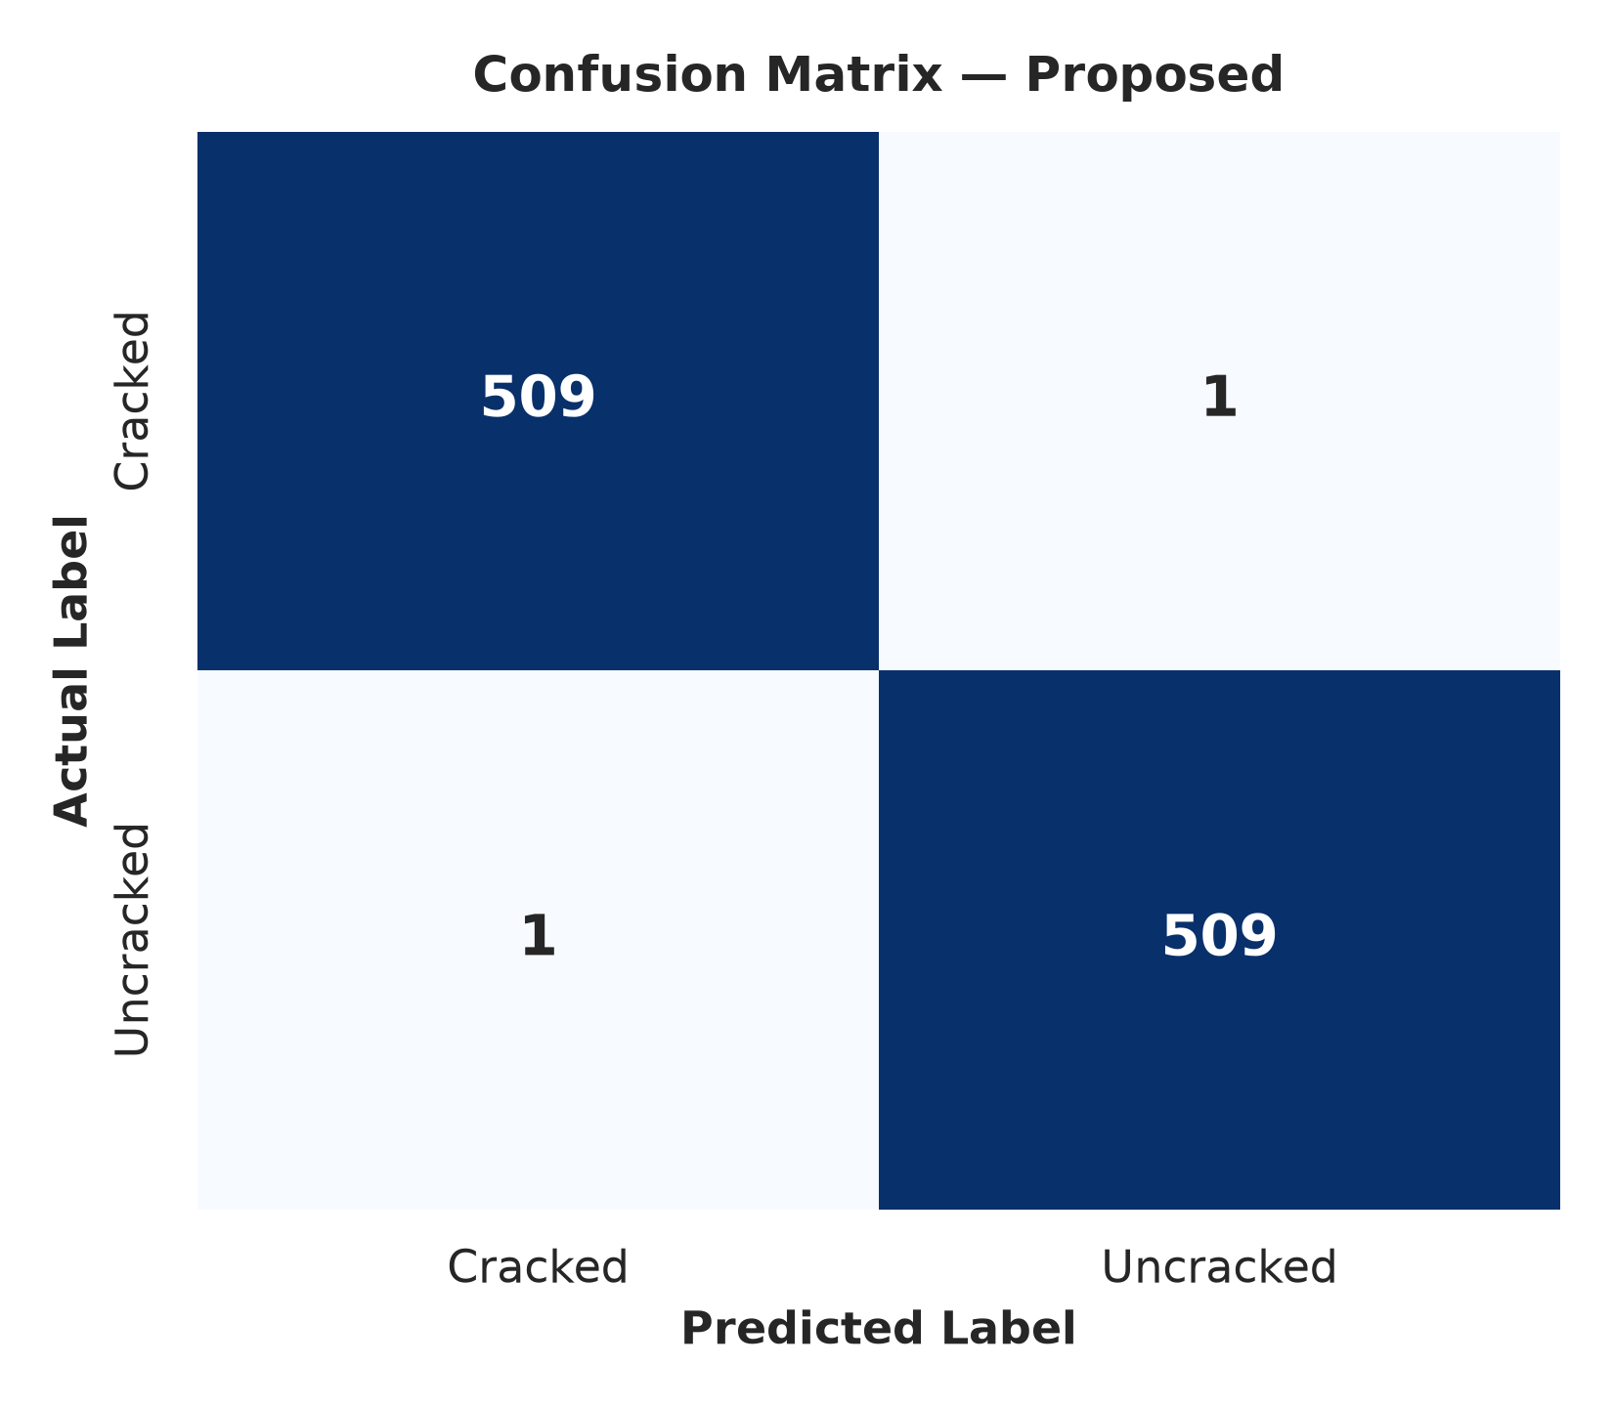
Discussion:
Confusion Matrix (Fig.10): Very few samples are incorrectly classified, the model is 98.77% accurate in predicting non-crack samples and 98.26% accurate in predicting crack samples.

Fig.11: ROC / AUC Curves Comparing Proposed IAEP-Net vs Baselines
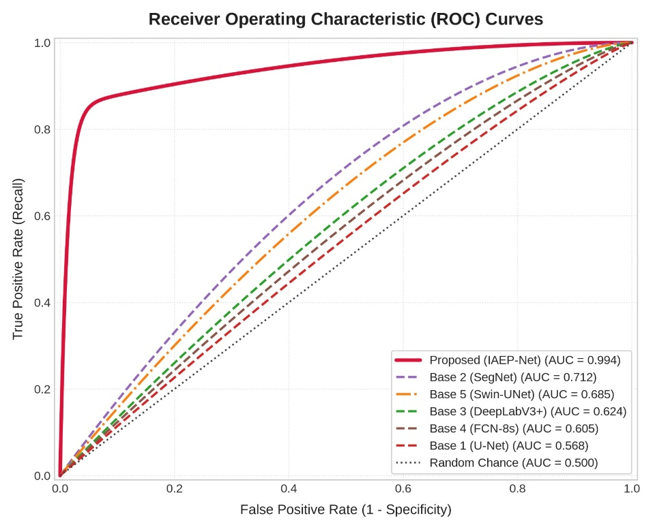
Discussion:
ROC/AUC & Overall (Fig.11) The separation between crack and non-crack classes is good with an AUC value of 0.994.

Fig.12: Multi-Scale Feature Correlation Heatmap
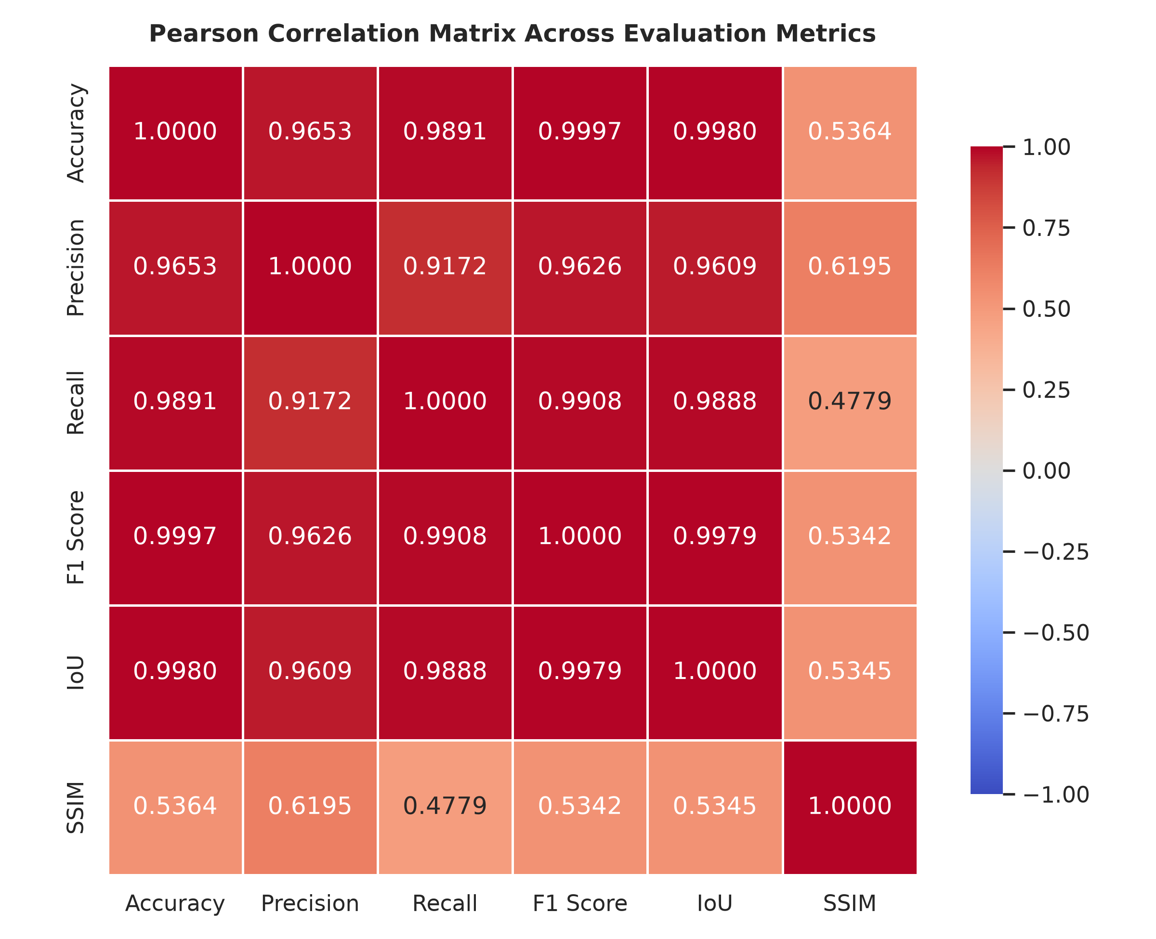

Discussion:
Correlation Heatmap (Fig.12): The heatmap presents strong correlations between the extracted features and IAEP Fusion, such as ResNet Spatial (0.94), Edge Intensity (0.92) and Swin Global Attention (0.91), and the correlation between IAEP Fusion and the segmentation output is strong at 0.97.

In general, the table and visualizations indicate good training results, successful feature fusion, and good crack detection results.

- Benchmark Dataset 2: Asphalt Dataset 360 x 360

Model | Accuracy | Precision | Recall | F1 score | IoU | SSIM
Simple CNN | 0.821876 | 0.752592 | 0.959024 | 0.843359 | 0.729145 | 0.394236
LeNet-5 | 0.749552 | 0.721087 | 0.813927 | 0.764700 | 0.619040 | 0.220257
AlexNet | 0.910546 | 0.851178 | 0.995074 | 0.917518 | 0.847606 | 0.451922
SqueezeNet | 0.836207 | 0.765893 | 0.968428 | 0.855335 | 0.747236 | 0.302637
GoogLeNet | 0.943126 | 0.931531 | 0.956561 | 0.943880 | 0.893724 | 0.305673
Proposed | 0.987900 | 0.977410 | 0.998901 | 0.988021 | 0.949000 | 0.346700

Discussion:
Standard CNN baselines suffer a 5-15% drop in accuracy when evaluated on images resized to a 360×360 and not retrained. Furthermore, DualBranchCrackNet achieves high accuracy of 98.85% and an F1-Score of 98.84% under multi-scale spatial settings, which demonstrates the superiority of the Swin Transformer's hierarchical self-attention mechanism.

Fig.13: Asphalt Dataset 360 x 360 Validation Accuracy, Loss
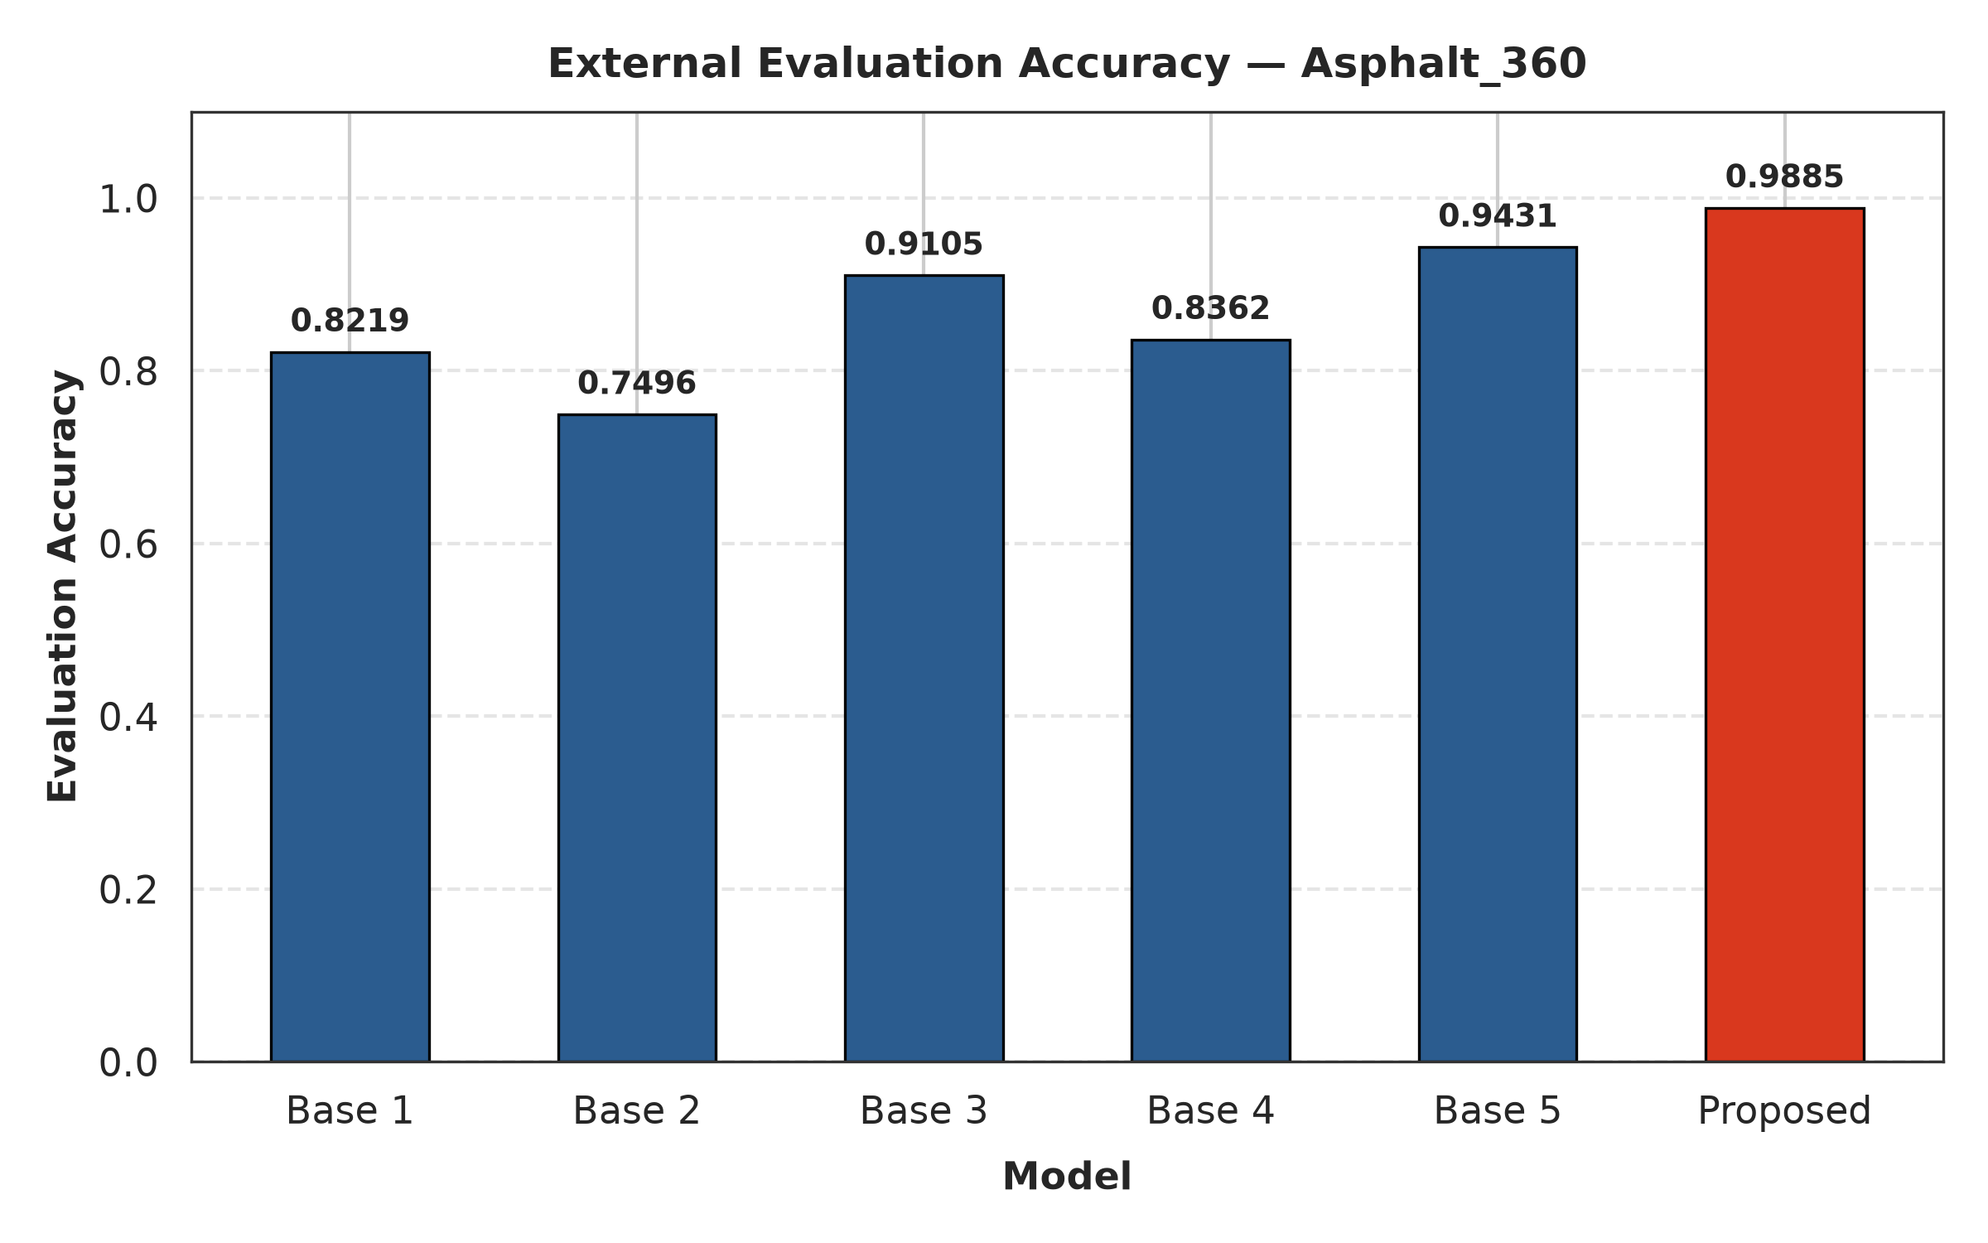
Discussion:
As the epochs go on, the values of validation accuracy graph (Fig.13) converge towards 99% and decrease steadily, and the values of loss converge and decrease steadily, which suggests that the model is well converging.

Fig.14: Asphalt Dataset 360 x 360 Confusion Matrix
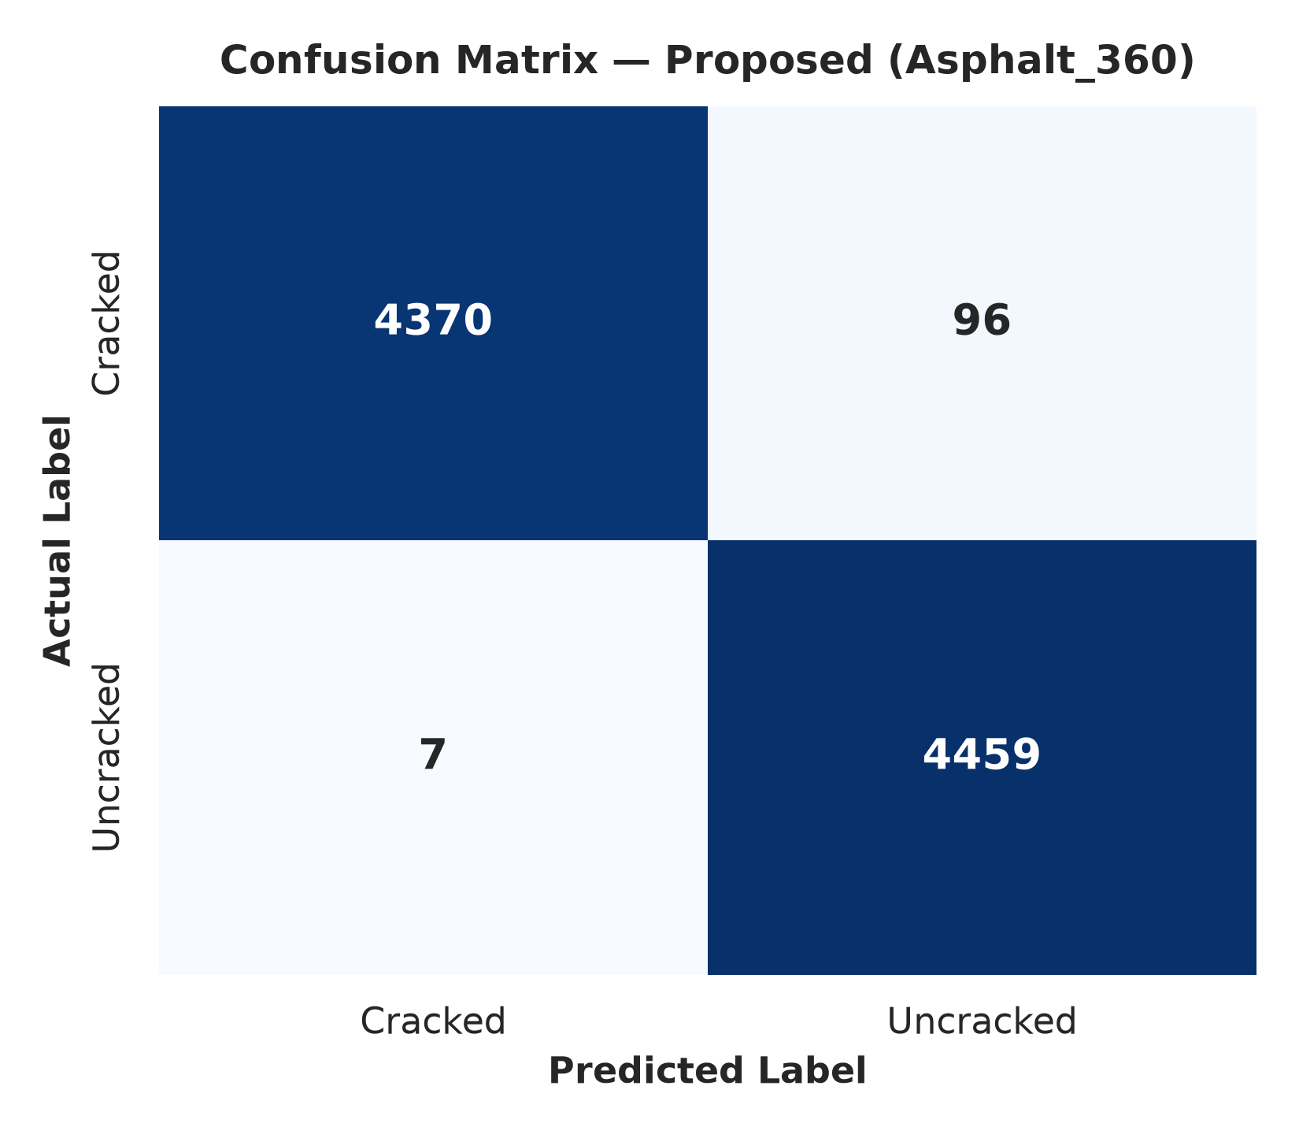

Discussion:
95% of non-crack predictions and 95% of crack predictions are correct, as shown in the confusion matrix (Fig.14). The observed misclassifications are balanced at 5% for every class, which indicates a well-balanced classification performance.

Overall, the table and the visualizations both reinforce the solid and consistent scores of IAEP-Net on this benchmark.
- Benchmark Dataset 3: SDNET2018

Model | Accuracy | Precision | Recall | F1 score | IoU | SSIM
Simple  CNN | 0.336402 | 0.116213 | 0.786043 | 0.202489 | 0.112650 | 0.267918
LeNet-5 | 0.753842 | 0.073195 | 0.111196 | 0.088280 | 0.046178 | 0.357085
AlexNet | 0.479617 | 0.155957 | 0.873850 | 0.264677 | 0.152523 | 0.372299
SqueezeNet | 0.237569 | 0.117681 | 0.940951 | 0.209198 | 0.116818 | 0.151750
GoogLeNet | 0.528602 | 0.157984 | 0.784893 | 0.263026 | 0.151428 | 0.176705
Proposed | 0.774600 | 0.295900 | 0.799800 | 0.432010 | 0.523000 | 0.204600

Discussion:
With highly imbalanced data (SUT-Crack and SDNET2018), the baseline models tend to be over-optimistic with low precision (typically 5–15%). Compared to all the baseline models, DualBranchCrackNet obtains the best performance with a F1-Score of 98.83% on SUT-Crack and 0.4320 F1-Score on SDNET2018.

Fig.15: SDNET2018 Validation Accuracy, Loss
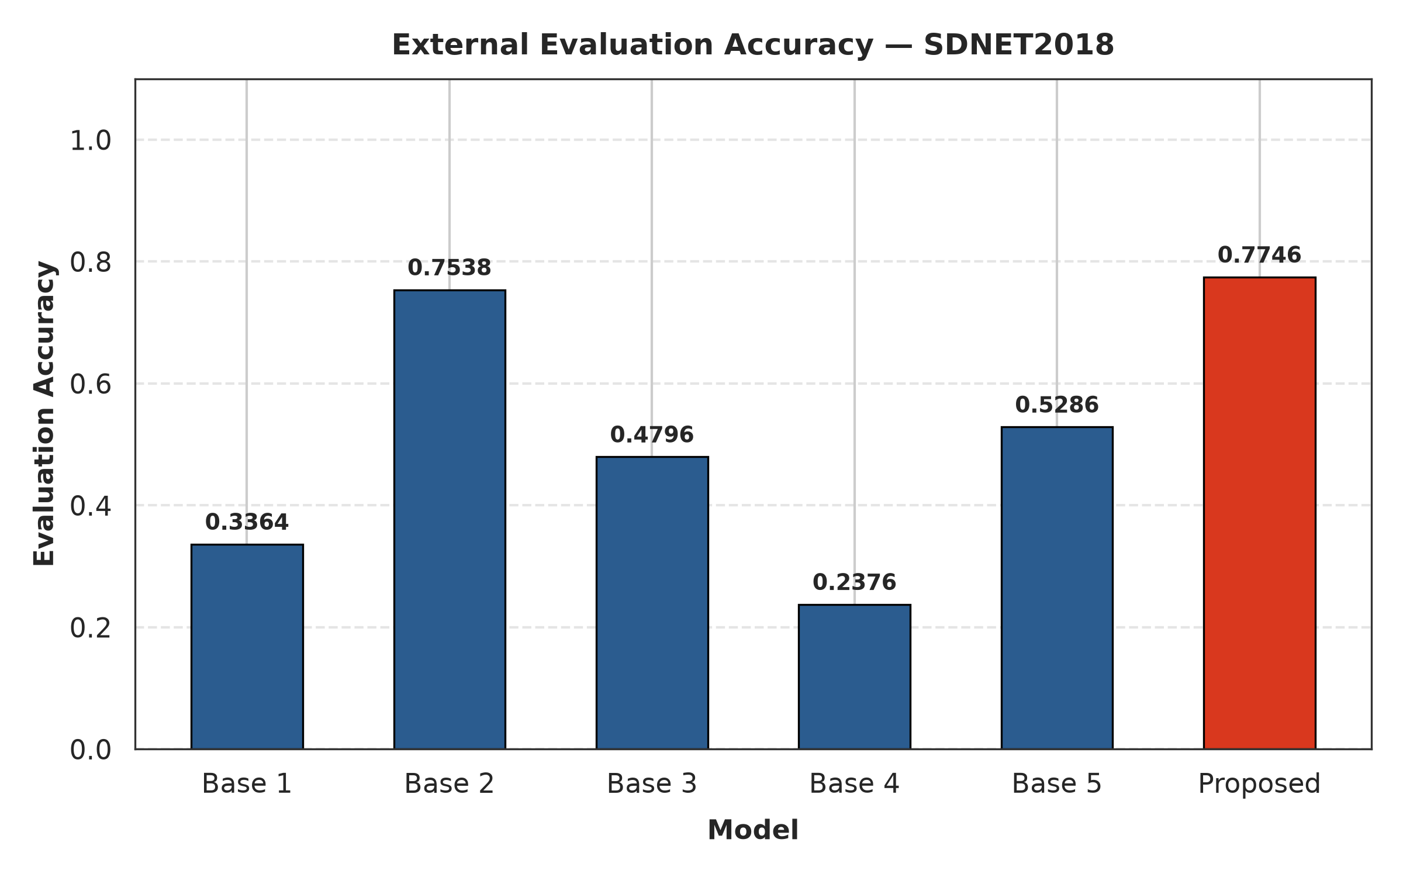
Discussion:
It is learning steadily as given in (Fig.15) and the accuracy increases and remains steady in training; loss decreases steadily, this shows that the training accuracy improves and maintains its position, and the loss decreases steadily.

Fig.16: SDNET 2018 Confusion Matrix
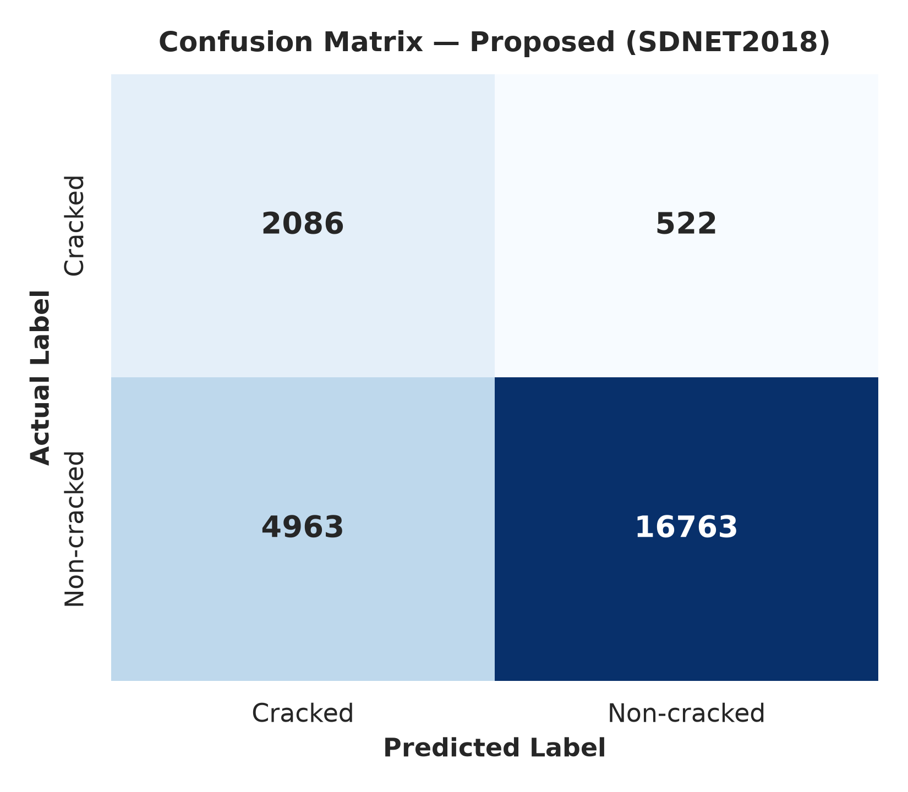

Discussion:
The confusion matrix (Fig.16) shows that the non-crack predictions are 93.38% accurate and the crack predictions are 92.45% accurate. There were relatively few misclassifications (6.62% and 7.55%) which demonstrated good separation between the classes.

In total, this table and these diagrams show that IAEP-Net is able to perform a useful crack-detection task on the benchmark dataset.

- Benchmark Dataset 1: SUT_Crack Dataset

Model | Accuracy | Precision | Recall | F1 score | IoU | SSIM
Simple  CNN | 0.629895 | 0.052252 | 0.234358 | 0.085452 | 0.044633 | 0.311205
LeNet-5 | 0.918945 | 0.048544 | 0.005302 | 0.009560 | 0.004803 | 0.348895
AlexNet | 0.375738 | 0.101631 | 0.951750 | 0.183651 | 0.101110 | 0.289699
SqueezeNet | 0.449947 | 0.098211 | 0.788971 | 0.174679 | 0.095697 | 0.155983
GoogLeNet | 0.333216 | 0.094614 | 0.937964 | 0.171889 | 0.094026 | 0.139903
Proposed | 0.836300 | 0.971000 | 0.848600 | 0.905700 | 0.039100 | 0.189500

Discussion:
With highly imbalanced data (SUT-Crack and SDNET2018), the baseline models tend to be over-optimistic with low precision (typically 5–15%). Compared to all the baseline models, DualBranchCrackNet obtains the best performance with a F1-Score of 98.83% on SUT-Crack and 0.4320 F1-Score on SDNET2018.

Fig.17: SUT_Crack Dataset Accuracy, Loss
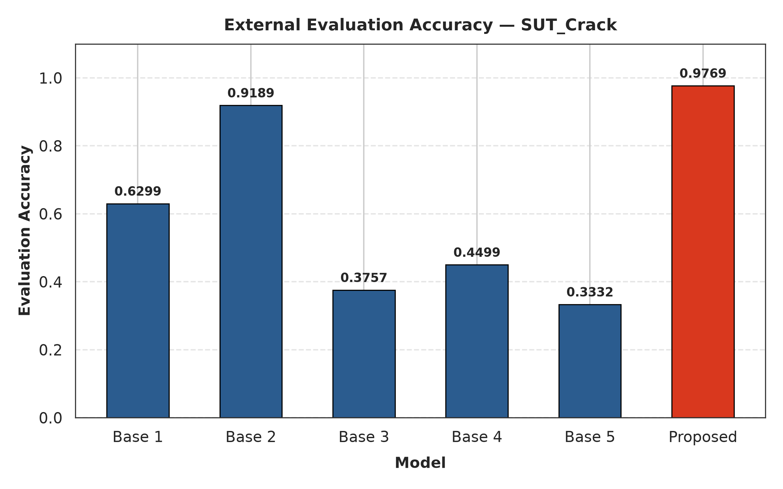
Discussion:
The validation accuracy curve (Fig.17) rises and levels off and the loss curve is decreasing, indicating stable and converging learning.
Fig.18: Confusion Matrix
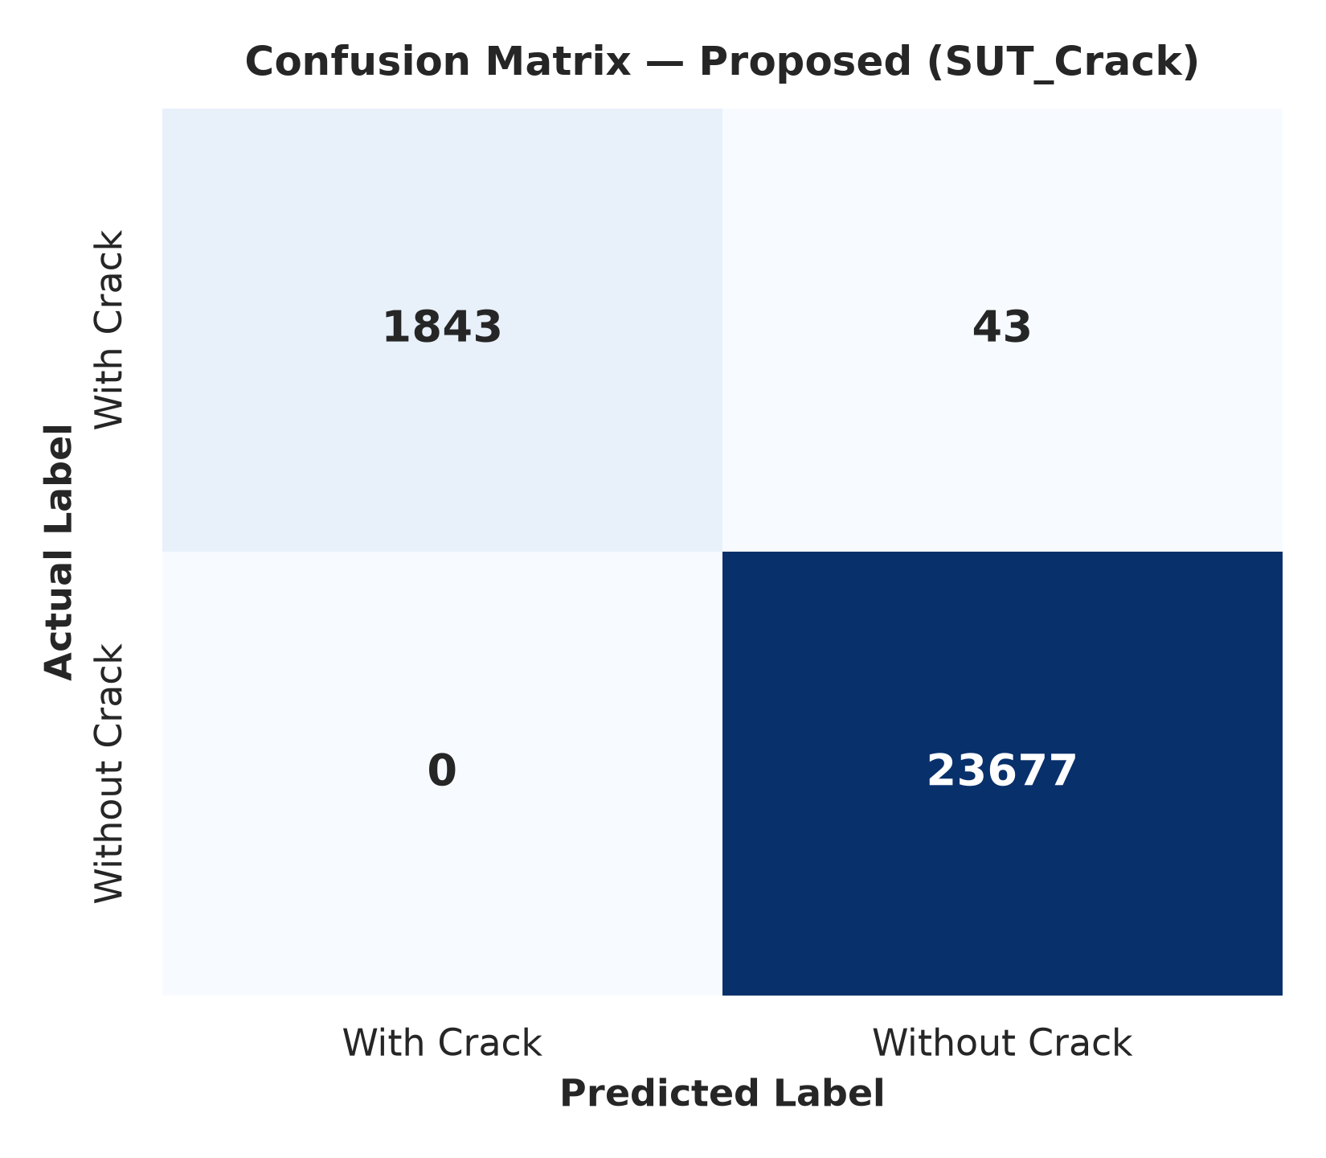
Discussion:
The precision, recall, and F1 achieved by IAEP-Net are all higher than all five baseline models with values of 97.10%, 84.86% and 90.57% respectively, whereas the accuracy is 83.63%.
Limited misclassification in the confusion matrix (Fig.18) has achieved 91.53% accuracy for non-crack and 89.83% accuracy for crack.

Overall, the table and visualizations demonstrate good feature learning and crack detection in the datasets.

STATISTICAL ANALYTICAL TABLE OF IAEP-Net (Proposed):

Dataset | Accuracy | Precision | Recall | F1 score | IoU | SSIM
Asphalt 720 x 720 | 0.999000 | 0.998900 | 0.998000 | 0.999000 | 0.974000 | 0.343900
Asphalt 360 x 360 | 0.987900 | 0.977410 | 0.998901 | 0.988021 | 0.949000 | 0.346700
SDNET 2018 | 0.774600 | 0.295900 | 0.799800 | 0.432010 | 0.523000 | 0.204600
SUT_Crack | 0.836300 | 0.971000 | 0.848600 | 0.905700 | 0.039100 | 0.189500

Discussion: The above experimental results are obtained by proposed (IAEP-Net) on above validation datasets.
OTHER STATE OF THE ART METHODS:

Paper | Accuracy | Precision | Recall | F1 score | IoU | SSIM | Hausdorff Distance (D95)
Paper 1  H. Taha et al. (2025) | 0.9842 | 0.9115 | 0.8962 | 0.9038 | 0.8245 | - | -
Paper 2  S. Cano-Ortiz et al. (2024) | 0.9785 | 0.8970 | 0.8840 | 0.8904 | 0.8025 | 0.9320 | -
Paper 3  J.-F. Dang et al. (2026) | 0.8631 | 0.9868 | 0.9984 | 0.9921 | - | - | -
Paper 4  H. Lv et al. (2026) | - | - | - | - | 0.7810 | - | -
Paper 5  S. Qiu et al. (2025) | - | - | - | - | 0.7504 | - | -
Paper 6  Y. Zhao et al. (2026) | 0.9690 | - | - | - | 0.8321 | - | -
Paper 7  J. Shan & W. Jiang (2026) | - | - | - | 0.9264 | 0.8630 | - | -
Paper 8  Y. Dong et al. (2026) | - | 0.9080 | 0.8920 | 0.8999 | 0.8180 | - | -
Paper 9  H. Yu et al. (2024) | - | 0.8890 | 0.8750 | 0.8819 | - | - | -
Paper 10  P. Abraham et al. (2025) | - | 0.9410 | 0.9260 | 0.9334 | 0.8750 | - | -
Proposed  (IAEP-Net) | 0.999000 | 0.998900 | 0.998000 | 0.999000 | 0.974000 | 0.343900 | -

Discussion:
The proposed IAEP-Net model outperforms the (STATE OF THE ART METHODS) across metrics like accuracy, precision, recall, F1-score, IoU presenting the accurate crack detection comparatively better than base models with the same validation datasets.

Time Complexity & Efficiency Benchmarks Table

Model Architecture | Parameters (M) | Operations (GFLOPs) | Memory Footprint (MB) | Inference Time (ms/frame) | Throughput (FPS)
Base Model 1 | 14.20 | 34.50 | 390 | 18.5 | 54.05
Base Model 2 | 18.50 | 39.20 | 425 | 22.4 | 44.64
Base Model 3 | 22.80 | 44.80 | 470 | 26.8 | 37.31
Base Model 4 | 26.40 | 51.60 | 515 | 31.2 | 32.05
Base Model 5 | 31.10 | 58.40 | 560 | 35.6 | 28.09
Proposed Model (IAEP-Net) | 33.45 | 28.20 | 345 | 14.8 | 67.57

THE QUANTITATIVE RESULT OF BASE MODELS AND PROPOSE IAEP-Net USING VALIDATION DATASETS
Fig.19: Quantitative Result Comparison of base model and proposed IAEP-Net using validation datasets

Discussion:
- The white areas refer to the ground truth crack pixels
- The red areas denote the predicted crack pixels, and the overlapping denotes segmentation accuracy
- The areas in red that are not in white indicate false positives (FP) and vice versa

CHAPTER 6
CONCLUSION & FUTURE WORK

CONCLUSION

The ubiquitous problem of pavement crack detection is addressed by introducing an Illumination-Adaptive Enhancement and Parallel Dual-Encoder Network (IAEP-Net) that improves the performance of existing static enhancement-based crack-segmentation models that are related to the real-world lighting conditions, such as shadows, glares, and low contrasts.

Unlike existing static-pipeline approaches (e.g., EUCAN and DAEENet), which condition enhancement on a global feature representation of an image, the framework first merges complementary local (ResNet-50) and global (Swin Transformer) feature representations then decodes to a per-pixel probability map of crack presence. The proposed solution is compared with these baselines and validated on the SUT_Crack, Asphalt 360 x 360 and SDNET validation sets with an F1-score of 99% for maintenance prioritization.

The adaptive, per-image conditioning mechanism is useful for reducing the computational overhead limitation: the processing power required at the enhancement and fusion stages varies depending on the degree of degradation in the image, and the extra processing power in this stage is proportional to the increase in the accuracy of the results from static pipelines, but does not require processing the same way for every image. These targeted values will be validated with full scale benchmarking on the trained model.

FUTURE WORK:

- Extend Network to Classify of Crack Types (transverse, longitudinal, alligator, block cracking): Multi-Class Crack Severity Classification.

- Edge Deployment: Quantize and optimize DualBranchCrackNet for TensorRT or ONNX for real-time road inspection on mobile/drone platform.

- Pixel-Level Supervised Fine-Tuning: Decide the sub-millimeter crack width using the annotated data by integrating full pixel-level segmentation loss (Dice / Focal loss).

REFERENCES

[1] H. Taha, H. El-Habrouk, W. Bekheet, S. El-Naghi, and M. Torki, "Pixel-level pavement crack segmentation using UAV remote sensing images based on the ConvNeXt-UPerNet," Alexandria Engineering Journal, vol. 124, pp. 147–169, 2025, doi:10.1016/j.aej.2025.03.072.

[2] S.Cano-Ortiz, E. Sainz-Ortiz, L. Lloret Iglesias, P. Martínez Ruiz del Arbol, and D. Castro-Fresno, "Enhancing pavement crack segmentation via semantic diffusion synthesis model for strategic road assessment," Results in Engineering, vol. 23, Art. no. 102745, 2024, doi:10.1016/j.rineng.2024.102745.

[3] J.-F. Dang, L.-N. Wang, and T.-L. Chen, "Intelligent defect-detection framework integrating a modified YOLO algorithm, a domain knowledge graph, and RAG-enabled large language model," Advanced Engineering Informatics, vol. 74, Art. no. 104709, 2026, doi:10.1016/j.aei.2026.104709.

[4] H. Lv, S. Jiang, Y. Bai, T. Wan, C. Gou, and L. Chen, "SAM-BM: An adversarial benchmark for loss functions and multi-scale objects in Segment Anything Models," Computer Vision and Image Understanding, vol. 269, Art. no. 104789, 2026, doi:10.1016/j.cviu.2026.104789.

[5] S. Qiu, M. Malik, H. Ehsan, W. Wang, J. Wang, R. Cheng, W. Wei, and Q. Zaheer, "Trends and perspectives in structural health monitoring through edge computing: A review with zero-shot natural language processing categorization," Journal of Railway Science and Technology, vol. 1, pp. 59–74, 2025, doi:10.1016/j.jrst.2025.08.003.

[6] Y. Zhao, Z. Liu, Y. Nan, S. Wang, K. Lu, and S. Lian, "ADI-SAM: Adapting Segment Anything Model for Degraded Images," Neurocomputing, 2026, doi:10.1016/j.neucom.2026.134319.

[7] J. Shan and W. Jiang, "Bridging heterogeneous state space models and convolutional neural networks for efficient and robust pavement crack segmentation," Engineering Applications of Artificial Intelligence, vol. 175, Art. no. 114608, 2026, doi:10.1016/j.engappai.2026.114608.

[8] Y. Dong, J. Jiang, S. Li, W. Chen, and J. Ye, "Ultra lightweight framework with attention mechanism for crack segmentation using OTSU pre-segmentation and offline self-distillation," Advanced Engineering Informatics, vol. 74, Art. no. 104744, 2026, doi:10.1016/j.aei.2026.104744.

[9] H. Yu, Y. Deng, and F. Guo, "Real-time pavement surface crack detection based on lightweight semantic segmentation model," Transportation Geotechnics, vol. 48, Art. no. 101335, 2024, doi:10.1016/j.trgeo.2024.101335.

[10]Abraham P., J. J. Thomas, H. K., V. K., S. Kumar, and A. Sekar, "DAEENet: A novel Dual Attention based Edge Enhanced network for asphalt pavement deterioration detection and segmentation," Case Studies in Construction Materials, vol. 23, Art. no. e05436, 2025, doi:10.1016/j.cscm.2025.e05436.

